Fuel Cells and Hydrogen
Joint Undertaking (FCH JU)
4th Stakeholders General Assembly
Preliminary programme

"Towards the deployment of Fuel cells and Hydrogen technologies"

Charlemagne Building
Rue de la Loi 170, B-1000 Brussels

Preliminary programme with invited speakers
23 November 2011

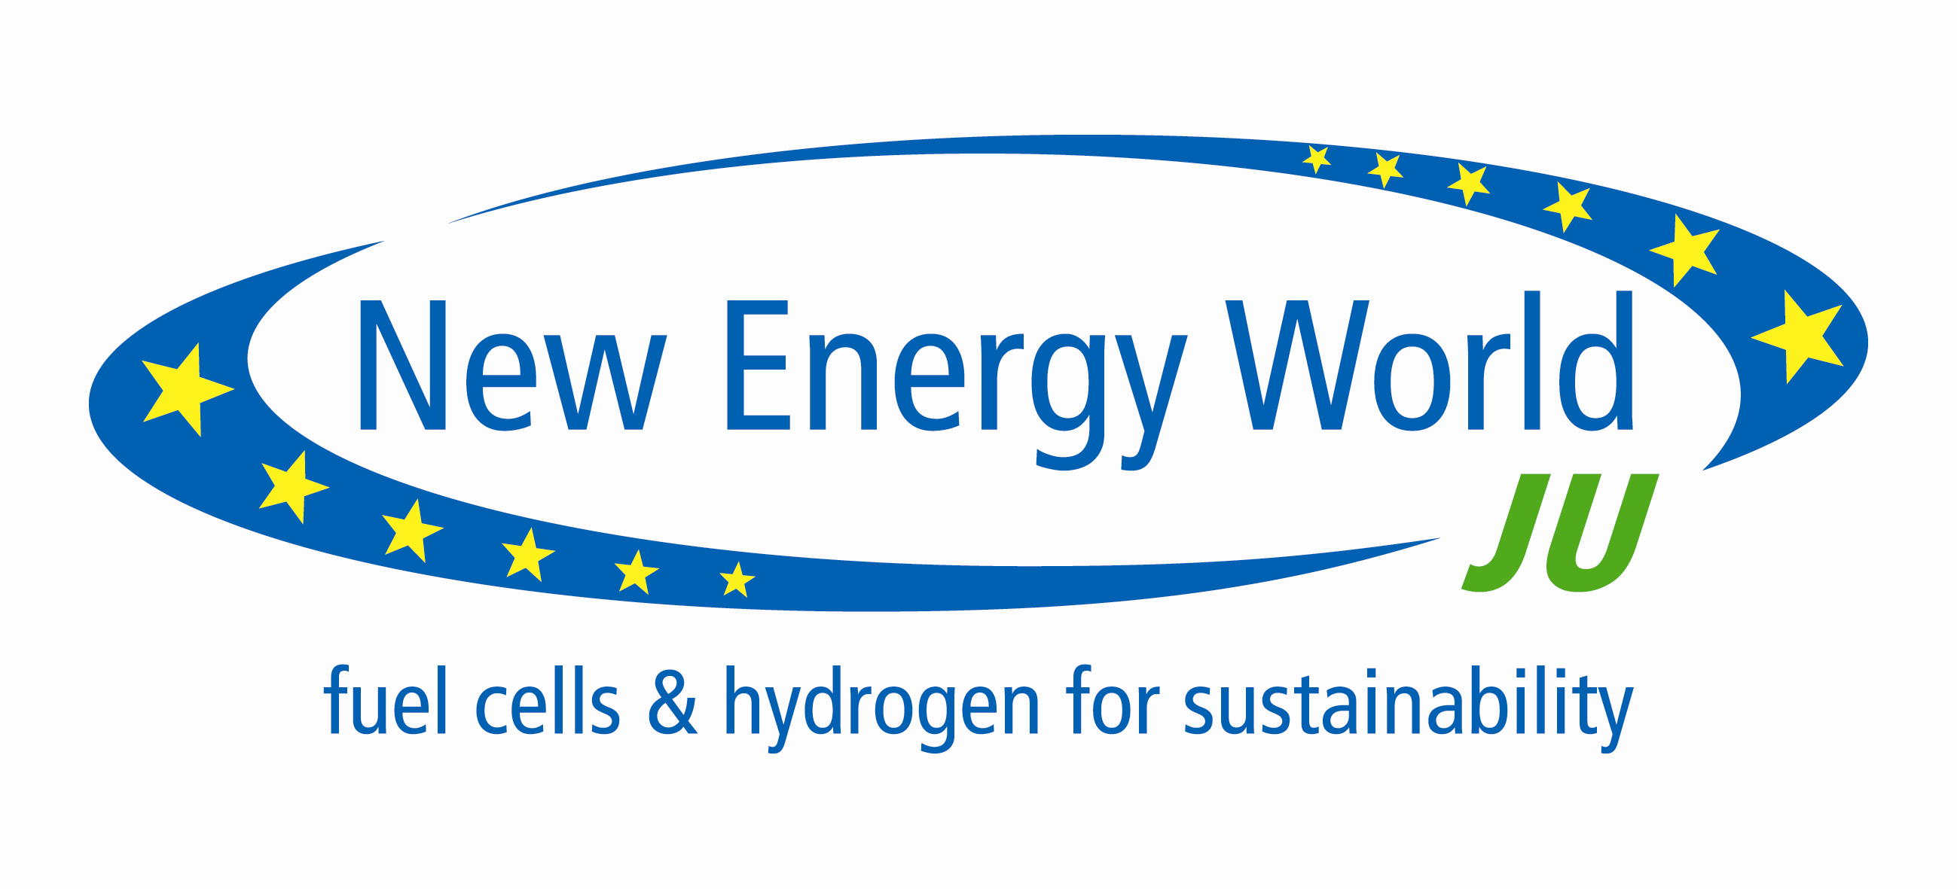

8h30 - 9h00
Registration and welcome coffee

Session 1: Decarbonising Europe’s Economy: a public private effort

9h00-9h30
Europe has reached a critical stage in achieving its decarbonisation objectives by 2050. Hydrogen and fuel cell technologies are key in that respect. With limited available financial resources and the investment climate under pressure, concerted action between all stakeholders is vital to ensure successful integration of fuel cells and hydrogen in the European energy and transport system. This opening session will set out the context of the conference providing “food for thought” throughout the rest of the day.

9h00 - 9h10: Welcome by Pierre-Etienne Franc, Chairman of the FCH JU Governing Board
9h10 - 9h30: Key note speech, Mr Nicolas Stern, Professor of Economics and Government
at the London School of Economics. Expert on Economic Development and Climate Change (invited)

Session 2: FCH JU: the first successful SET- PLAN public private partnership

9h30 – 10h30
The Fuel Cells and Hydrogen Joint Undertaking (FCH JU) was set up in 2008 as the first public/private partnership under the SET-plan, with a budget of ~1 €bn, shared between the European Commission, Industry and Research sector. In this session, the partners in this joint undertaking will, from experience, discuss what has been achieved so far (2008 – 2011) and look at the future role of public-private partnerships. The session will highlight FCH-JU achievements and breakthroughs and look into areas for further developments, taking into account the Programme review and the mid-term evaluation of the programme.
Panel discussion

Moderator: Raffaele Liberali, Director of directorate Energy, DG Research and Technological
development, European Commission
Bert De Colvenaer, Executive Director of the FCH-JU
Henri Winand, CEO of Intelligent Energy, Treasurer NEW-IG
Paul Lucchese, Director new energy technologies, Commissariat à l’Energie
Atomique, Chairman N.ERGHY
Knut Harg, Chairman of the Scientific Committee and of the Programme review
Bernard Frois, Director, Management Unit of New Energy technologies, CEA, Chairman of
the States Representatives Group

Q&A with the audience (15 min)

10h30 - 11h00
Coffee break and networking

Session 3: From Concept to Reality: a concerted approach to integrate FCH technologies into future energy and transport systems

11h00 – 13h00
Hydrogen and fuel cells technology has reached a decisive stage. To date, huge investments have been made by all stakeholders to progress technological development. Regulatory and adequate financing mechanisms are needed to overcome the last obstacles to market entry and encourage early adopters to take the lead. Industrial and political leaders will address questions like: What is needed for market-deployment of clean alternative technologies? How can the public and private sector achieve together a low carbon economy by the integration of these FCH technologies in the future energy and transport system?
Panel discussion

Moderator –journalist
Keynote Speech : Günther Oettinger, Commissioner for Energy (invited)
Dr. Dieter Zetsche, Chairman of the Board of Management and Head of Mercedes-Benz
Cars Daimler AG (invited)
Mathieu Grosch, MEP, EPP-ED (invited)
Benoît Potier, Chief Executive Officer , Air Liquide (invited)
Maciej Banach, Under-Secretary of State, Ministry of Science and Higher Education
(invited)

Mikael Ohlsson, President and Chief Executive Officer of Ikea (invited)
Maria Da Graça Carvalho, MEP

+Q&A with the audience (30 min)

13h00-14h15: Lunch and networking

Session 4: Appropriate regulatory and financial frameworks required to bring innovation –
including FCH - to the market

14h30-16h00
One of the key questions is how to bring innovation to the market. Since the introduction of clean technologies is driven by societal choices rather than economic ones, the market will not cater for change by itself. What is needed to bridge the gap between successful demonstrations to commercial deployment of clean technologies? How to best combine national, regional and European initiatives? What are the current policy-gaps and how should these be over-come?
Panel discussion

Introduction and moderation: Jean Pisani-Ferry, Director of Bruegel Institute
Fotis Karamitsos, Director Directorate C innovative and sustainable mobility, DG MOVE,
European Commission (invited)
Graham Watson, MEP (invited)
Jeppe Tranholm-Mikkelsen, H.E Permanent Representative of Denmark to the EU
(invited)

Juan Alario, Energy Efficiency & Renewables, Head of Division & Associate Director of
European Investment Bank (invited)

Andreas Ziolek, Chairman of the European Regions and Municipalities Partnership for
Hydrogen and Fuel Cells

+ Q&A (30 min)

16h00 – 16h30: Coffee break and networking

Session 5: International perspective and co-operations

16h30- 18h00
Fuel Cells and Hydrogen technologies have long been identified as a great opportunity for innovation, economic growth and job creation, as well as a key option for long term emissions reduction. As both advanced and developing countries are investing huge amounts of money to prepare their economies and societies for fuel cells and hydrogen becoming one of the components for a clean energy future, how to ensure a coherent international approach? And where do we stand in the international spectrum? Speakers from around the world will share their national visions for FCH technology development and give their perspective on the European state of play.
Panel discussion

Moderator – Bert de Colvenaer, Executive Director FCH-JU
Walter Podolski, Office of fuel cell and hydrogen technologies, Department of Energy, USA
Dr Nan Hoon Kang, Director General for Energy policy, Ministry of knowledge, Economy,
industry, commerce and Energy, Korea (invited)
Mr Tadashi Ito, Chief Officer Fuel Cell & Hydrogen Technology Group, NEDO
(invited)
Dr Xin Li, Director, Div. of International Organizations and Conferences, Dept. of
International Cooperation, Ministry of Science and Technology, China
(invited)

Ms Micol Martinelli, Director of the SMEs sector, Eurochambers (invited)

+ Q&A (20 min)

17.45-18.00: Closing: Bert De Colvenaer, Executive Director FCH -JU

