STUDER Etienne  Research Engineer at CEA Saclay (France)  Thermalhydraulics and Fluid Mechanics Applications Lab (LATF)  Mail etienne.studer@cea.fr | 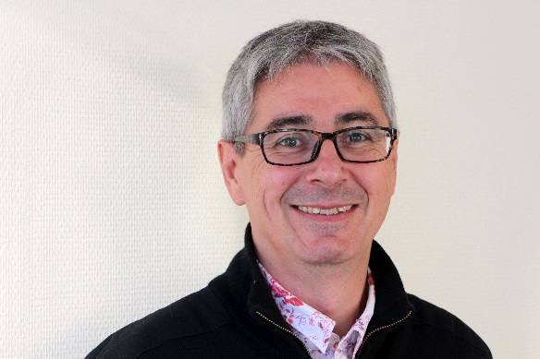

Curriculum

Etienne Studer has devoted his thirty years of research and development to nuclear safety and more particularly to hydrogen risk. First of all, in connection with the numerical aspects and validation of numerical tools of the macroscopic scale in "lumped parameter" models at the microscopic scale in CFD tools. In this context, he participated in projects of the 4th and 5th Framework Programs of the European Community such as HDC, H2DDT and HYCOM. He then joined CEA's MISTRA project to experimentally study hydrogen dispersion and risk mitigation in PWR containment. Numerous national and international projects have been conducted in this framework, such as International Standard Problem 47, the SETH-2 and HYMERES projects for OECD/NEA and the ERCOSAM project for the European Community. In parallel, with the development of the hydrogen energy sector, he participated with the other members of the laboratory in the NoE HYSAFE, in the NATURALHY project as well as in national projects such as DRIVE, DIMITHRY, HYDROMEL alongside the French actors of the sector: Air Liquide, INERIS etc.
Within the CEA, he carries out expertise on hydrogen risk management both in the experiments conducted in the institute and in its various nuclear installations: reactors, nuclear waste management, etc. Alongside EDF, it is participating in additional safety assessments of French nuclear power plants following the Fukushima accident, particularly on large-scale combustion modelling. Finally, he leads the collaboration between the CEA and numerous institutes in Europe and in Asia (Japan, China and India) on the topic of hydrogen risk and containment thermohydraulics.
Author of more than fifty publications in this field, he devotes part of his time to teaching combustion theory, hydrogen risk and numerical methods in French universities and Engineering High School. The supervision of doctoral students, the hosting of engineering trainees and apprentices allow the transmission of knowledge.

