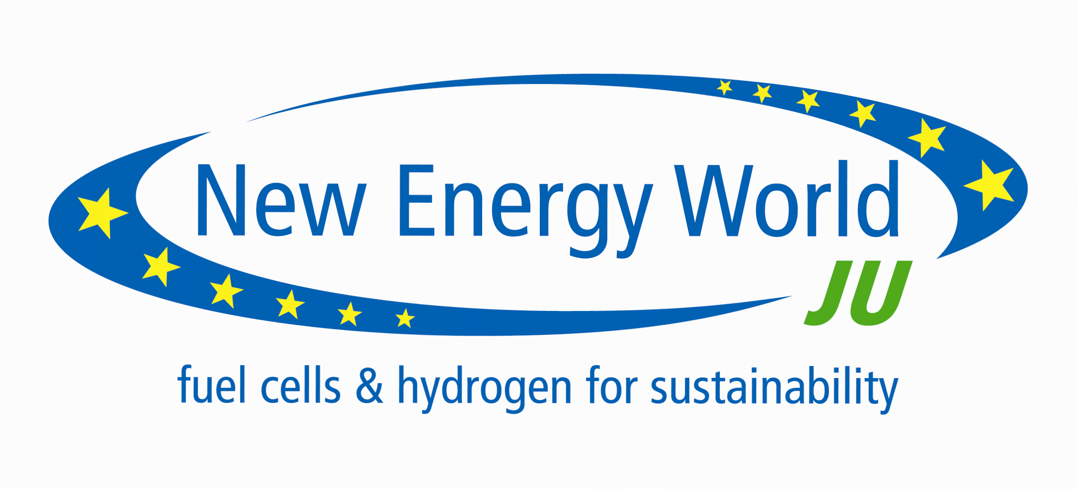

Public Information session in Call 2011
12 May 2011,
Tour Madou, Place Madou 1, 1200 Brussels

Agenda

14:00 -14:30 Registration of participants

14:30 – 14:50 The Fuel Cells and Hydrogen Joint Undertaking– State of Play
Claire Castel (Policy & Communication programme office), Ilse Van Hartevelt (Industry Grouping Secretariat), Joerg Nellen (Research Grouping Secretariat)

14:50 – 15:30 The Annual Implementation Plan 2011 (topics opened)
Carlos Navas (Project Manager programme office)

15:30 – 15:45 Coffee break

15:45 – 16:15 Proposals – from submission to selection
Mirela Atanasiu (Project Manager & Call coordinator programme office)

16:15 – 16:45 Questions & Answers

16:45 – 17:00 Closing remarks

