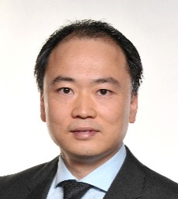
Jianjun Xiao
Institute of Nuclear and Energy Technologies
Karlsruhe Institute of Technology
Email: jianjun.xiao@kit.edu

Curriculum

Dr. Jianjun Xiao joined Karlsruhe Institute of Technology (KIT) as a researcher in 2006. He has more than 15 years of experience in numerical simulations and safety analysis. His research interests are high-performance computing of turbulent flows, combustion, conjugate heat and mass transfer, and multi-phase flows. He is the chief developer of parallel computational fluid dynamics (CFD) code GASFLOW. The code has been officially licensed by KIT and widely used for safety analysis by the nuclear industrial companies and research institutes in the world wide. He was actively involved in the ITER, SARNET, ICEFUEL and other projects related to hydrogen safety analysis in large scale industrial facilities. Author of more than 70 publications in the fields of CFD and hydrogen safety analysis.

