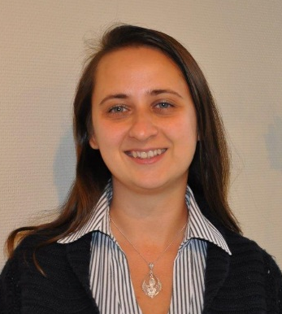
VYAZMINA Elena
R&D Engineer/Expert, Air Liquide (France)
Mail: elena.vyazmina@airliquide.com

Curriculum

Elena VYAZMINA. Born in Gorky region, USSR in 1983. MSc in Applied Mathematics and Physics (2006, Moscow Institute of Physics and Technology, Russia), PhD in Chemical Engineering (2007, Ishlinsky Institute for Problems in Mechanics, Russian Academy of Science, Russia), PhD in Fluid Mechanics (2010, Ecole Polytechnique, France).

In 2010 Elena started her research carrier at Air Liquide Paris Saclay R&D center as a research engineer in the Modeling Group. Since 2014 Elena became an internal expert in modeling for safety. In 2011 she participated in an internal Task Force dedicated to atmospheric dispersion of nuclear particles from Fukushima NPP. She worked on the modelling and design of mitigation means for pipeline leakages and ruptures, combustion of metals pure oxygen, fast filling of hydrogen cylinders, accumulation of hydrogen, explosions etc. She participated in multiple French and International Working Groups : ICSI (Institute for Industrial Safety Culture) preparing a French document “Best practice for PHAST modeling” for a WG of te Ministry of Ecology, Sustainable Development and Energy on Best practice guide “The use of 3D modeling of atmospheric dispersion for hazard studies”, INERIS WG “The use of CDF Explosion Approaches for Hazard Studies, WG of CGA (Compressed Gas Association) for the modeling of atmospheric dispersion of heavy gases.

Elena participated in the preparation and deliverance of Internal Training Courses at Air Liquide for Risk Managers. Elena is also involved in the promotion of hydrogen safety deployment via her participation at various salons (including the presentation of the hydrogen charging station during the COP 21 conference in Paris).

Elena was awarded a Golden Medal of Russian Academy of Science for young researchers in 2007. She has co-authored approximately 50 scientific international publications, half of them related to safety issuers of hydrogen. She participated in the preparation and execution of several FCH JU project (for example Preslhy, SAFIT and Hyindoor) also as a member of the advisory board for the Hysea project. She was also invited as an external expert for the expert workshop FCH JU SUSANA project

