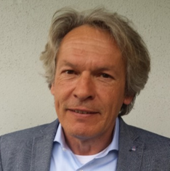
GRUNE Joachim,
Managing Director of Pro-Science GmbH
Karlsruhe (Germany)
Mail: grune@pro-science.de

Curriculum

Dipl.-Ing. Joachim Grune, born in Fürth, Bavaria, Germany in 1963, took up his professional activity in the field of hydrogen safety in 1998 as a chemical engineer, going on to set up his own company specializing in the provision of practical back-up services in connection with third-party scientific-experimentation work. He has been involved since 2000 at senior-management level at Pro-Science GmbH, an engineering firm. Pro-Science GmbH specializes in the field of hydrogen safety and provides a support service for the “Hydrogen Group” and the Hydrogen Test Center (HyKa) at IKET. He is a specialist in his field with 20 years’ practical experience in the implementation of hydrogen experiments for national and international, publicly and privately funded projects. He also offers a consultancy service for industrial companies in relation to practical applications in the area of hydrogen safety as well as training programs for students and Ph.D’s., focusing on experimentation work in the areas of hydrogen distribution and combustion. He has produced 80+ publications dealing with experimentation-related aspects of hydrogen safety.

