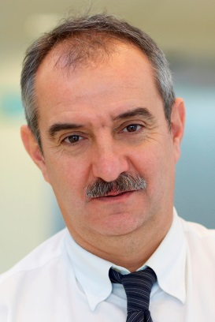

AZKARATE Iñaki
Programmes Research Director
Energy & Environment, TECNALIA (Spain)
Mail: inaki.azkarate@tecnalia.com

Curriculum

Iñaki Azkarate. Born in Bergara, Spain in 1956. Is Doctor Chemical Engineer by the Instituto Químico de Sarriá (IQS), Barcelona and Industrial Engineer by the Universidad Ramón Llull, Barcelona.
Has worked for the research organizations INASMET and TECNALIA since 1981 in the field of Materials and its behaviour in aggressive service conditions.
Has participated in a large amount of Research Projects mainly focussed in Energy applications. Has represented INASMET and TECNALIA in the Asociación Española de Hidrógeno (AEH), Asociación Española de Pilas de Combustible (APPICE), Plataforma Tecnológica Española de Hidrógeno y Pilas de Combustible (PTEHPC), NACE, Sociedad Nuclear Española (SNE), IA HYSAFE, Hydrogen Europe Research.
Member of the NoE HYSAFE and the H2FC project within the VII Framework Programme of the European Community.
Member of the Board of International Association HYSAFE, and the Organizing Committee of the ICHS (International Conference of Hydrogen Safety), Chair of the Energy Pillar of Hydrogen Europe Research.
Author of several publications in the field of corrosion and hydrogen embrittlement of materials.

