20

Fuel Cells and Hydrogen
Joint Undertaking (FCH JU)
5th Stakeholders’General Assembly
Preliminary programme

"Realising sustainable growth through
Fuel Cells and Hydrogen"

Maison de la Chimie
12 October 2012, Paris

Preliminary programme

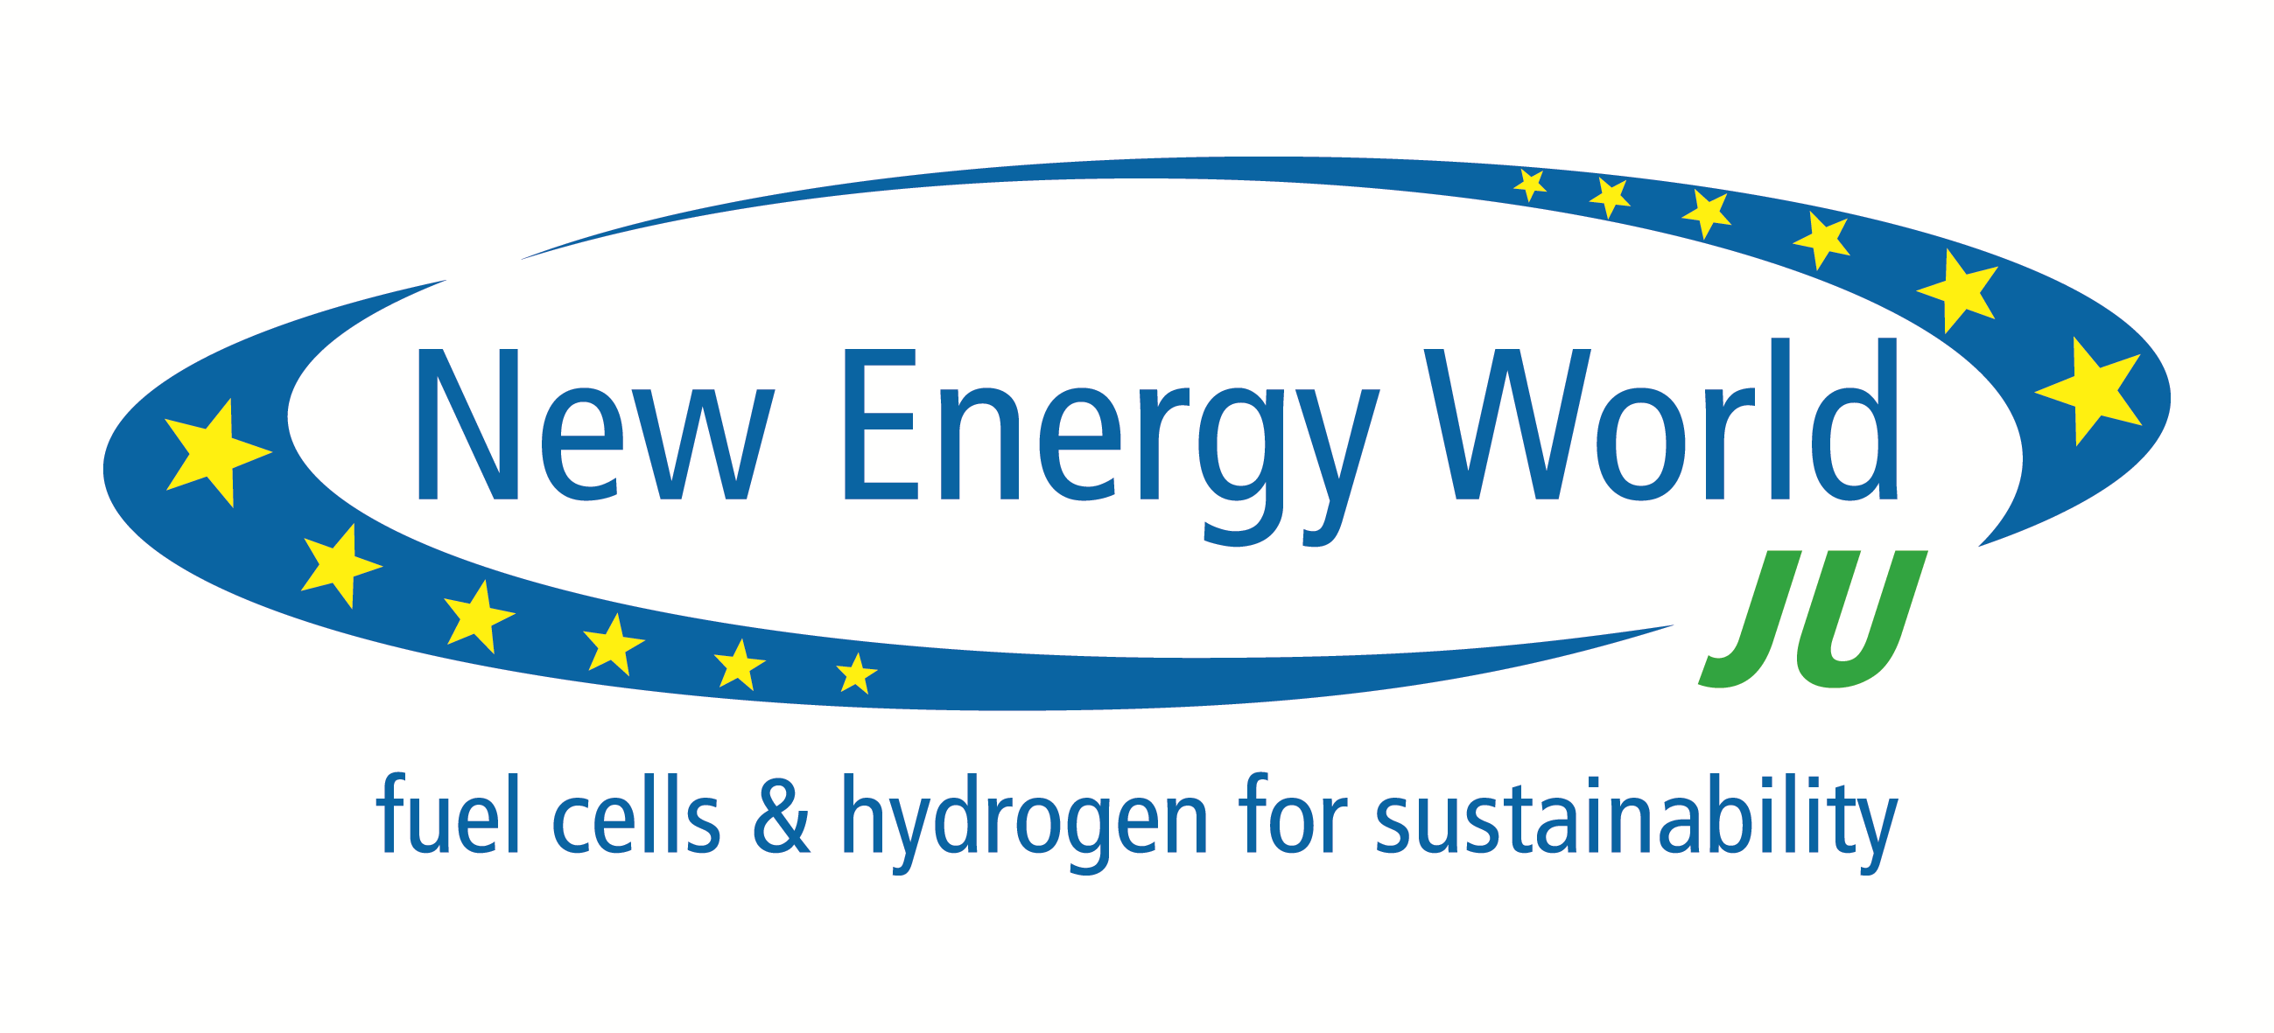

8h30-9h00
Registration and welcome coffee

9.00-10.00 Opening Session

Welcome: Pierre Etienne Franc, Chairman of the FCH JU Governing Board

13’ | Geneviève Fioraso, French Minister for Science and Research
13’ | Günther Oettinger, Commissioner for Energy, European Commission (tbc)
13’ | Benoît Potier, CEO of Air Liquide
13’ | Bernard Bigot, President of CEA

10.00- 11.00 Session I- Achievements and ambition for the FCH JU within horizon 2020
The Fuel Cells and Hydrogen Joint Undertaking (FCH JU) will review: the achievements in all application areas, the roadmap and its priorities, in the Horizon 2020 perspectives

13’ | FCH JU achievements and perpectives | Bert de Colvenaer, Executive Director FCH JU
13’ | FCH long- term technology roadmap 2013 and 2020 and priorities : Industry commitments | Henri Winand, CEO Intelligent Energy
13’ | Fuel Cells and Hydrogen in Europe 2020 | Rudolf Strohmeier, Deputy Director General, DG Research, European Commission
20’ | Exchange with the audience

11.00 – 11.30 Exhibition and Networking Coffee
11.30 – 13.00 Session II- Role of hydrogen and fuel cells in a decarbonised energy system

13’ | The prospects of H2 in a clean energy sytem | Ulrich Wagner, Board Director DLR
13’ | Low carbon H2 production | Jorg Müller, Chairman Enertrag (tbc)
13’ | Managing intermittency and the role of smart grids | Kim Behnke, Head of R& D, Energinet, Denmark (tbc)
13’ | Stationary deployment through the Ene-field project | Fiona Riddoch, Managing Director of Cogen Europe
13’ | Addressing energy challenges in Europe | Tudor Constantinescu, Director Energy Directorate, European Commission
 | Exchange with the audience

13.00 – 14.30 Exhibition and Networking –LUNCH for all participants

14.30 -16.00 Session III –Deployment initiatives and challenges for hydrogen infrastructure
build-up

13’ | Linking the H2 Mobility Plan to EU deployment strategy | Klaus Bonhoff, NOW
13’ | European support to infrastructure deployment | Olivier Onidi, Director, Transport Directorate, European Commission
13’ | Customer -based deployment strategy | Daryl Wilson, CEO Hydrogenics
13’ | Overcoming difficulties to deployment in the US | Catherine Dunwoody, California Fuel Cell Partnership (tbc)
25’ | Q&A and exchanges with the audience and with panellists

16.00 –16.30 Exhibition and Coffee
16.30-17.45 Session IV – Addressing the financial challenges to deployment

13’ | Nurturing promising technology developers | Private bank or venture capital association
13’ | Financial challenges of clean energy technology projects | Christopher Knowles, Head of climate change and environment division, EIB (tbc)
13’ | Attracting institutional/private investment for infrastructure development | Laure Reinhart, CEO, OSEO
20’ | Q&A with audience and exchanges

Closing remarks: Pierre-Etienne Franc

