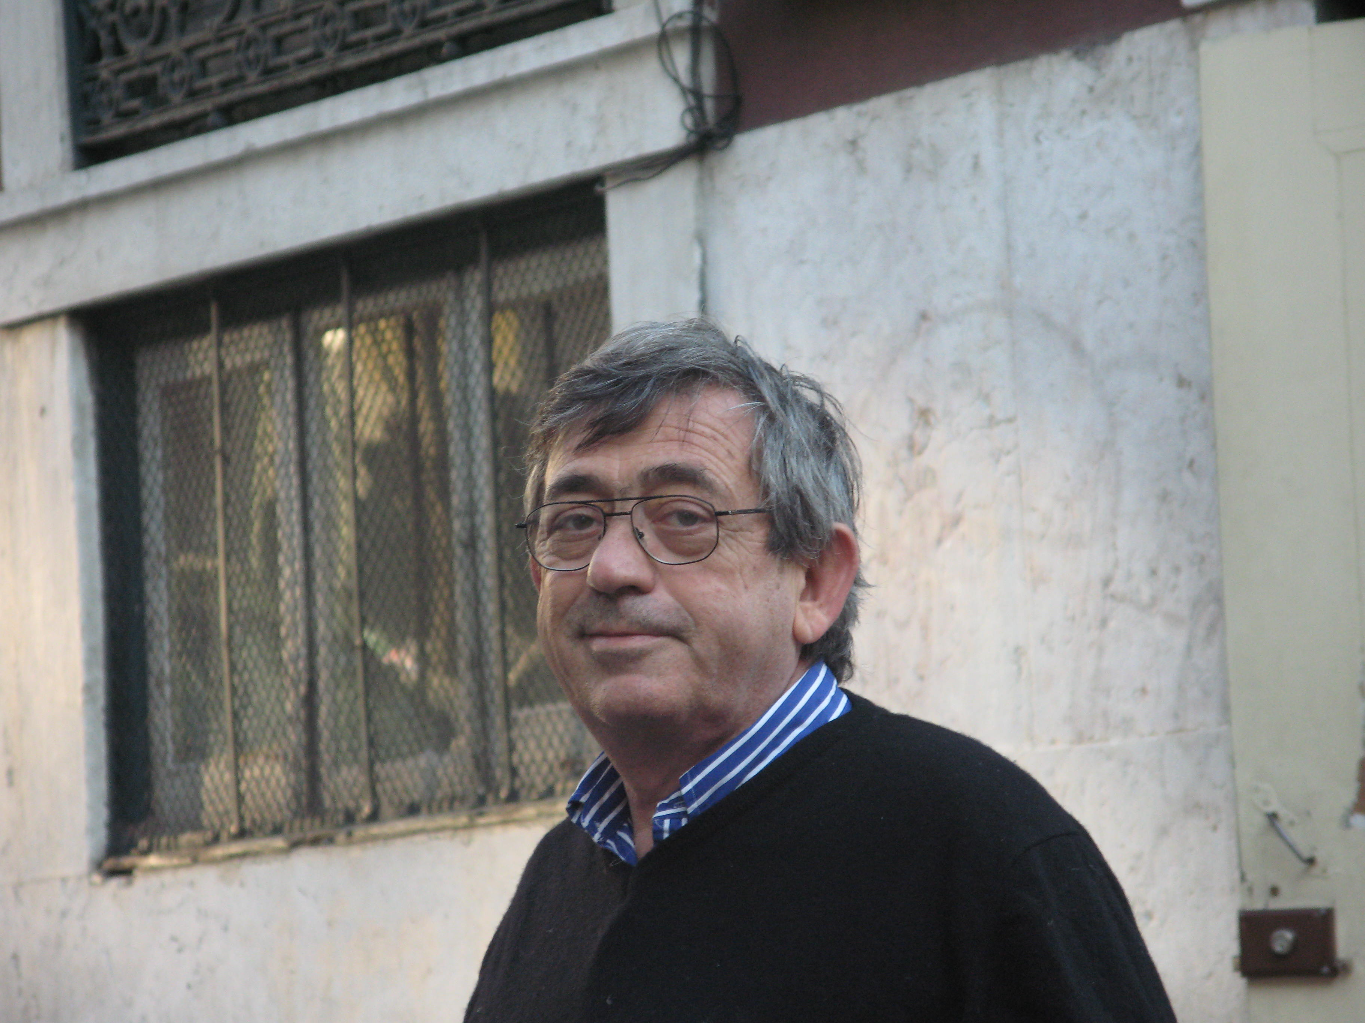

CARCASSI Marco Nicola
Professor at University of Pisa (Italy)
Department of Civil and Industrial Engineering (DICI)
Mail carcassi@ing.unipi.it

Curriculum

Professor Marco N. Carcassi has focused his research studies, in last thirty years, on Hydrogen Risk in Nuclear and Conventional plants. He has been visiting researcher for 12 months at the Sandia National Laboratory (Albuquerque, NM USA), and he was, in this field, scientific responsible of several national and international research projects. Coordinator of HYMI e VOASM projects, within the IV Framework Programme of the European Community related to the Hydrogen Risk in the nuclear plants, member of the NoE HYSAFE NoE and HYPER project within the VI Framework Programme of the European Community, member of H2FC project within the VII Framework Programme of the European Community and HYSEA project in the last EU programme. He was member of; the Board of the University of Pisa; scientific associations (Past-Chairman of the Forum Italiano dell’Idrogeno); the ESRA Editorial Board, of the Italian 3ASI association).
Inside the Italian Ministry of Interior has been appointed as member of Ad-Hoc Group (created by the Italian Fire Corps to draw up the fire prevention regulations for hydrogen applications), member of the Italian Thermochemical Committee, which is part of UNI which is the Italian body for standardisation, member of ISO/TC 197 “Hydrogen Technologies”,and IEA Task 31 “Hydrogen Safety”. Prof Carcassi is Chairman of the Organizing Committee of the series of Italian congresses VGR (Risk Assessment and Management in the Civil and Industrial Settlements) and, as member of the Board of International Association HYSAFE, chairman of the ICHS (International Conference of Hydrogen Safety).
Author of more than 200 publications in the fields of combustion and risk assessment, in particular for the hydrogen as energy carrier.

