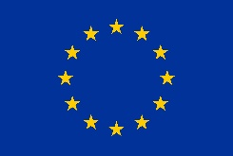

List of Decisions of the FCH 2 JU Governing Board for 2021

This document lists the decisions which were taken by the Governing Board of FCH 2 JU since 1 January 2021. The type of decision identifies which decisions were taken at a Meeting and which decisions were taken by Written Procedure (WP).

Reference | Type | Decision Title
FCH-GB-2021-01 | WP | Approval of 26 February 2021 of amendment n°1 to the FCH 2 JU AWP and Budget for 2021
FCH-GB-2021-02 | WP | Approval of 07 April 2021 of independent assessment of aggregate level of IK (FP7) at 31.12.2020
FCH-GB-2021-03 | WP | Approval of 15 June 2021 of the minutes of GB meeting of 24 March 2021
FCH-GB-2021-04 | WP | Approval of 31 May 2021 of amendment n°2 to the FCH 2 JU AWP and Budget for 2021
FCH-GB-2021-05 | WP | Assessment and approval of 15 June 2021 of the FCH 2 JU AAR 2020
FCH-GB-2021-06 | WP | Approval of 30 June 2021 of the FCH 2 JU final accounts for 2020

