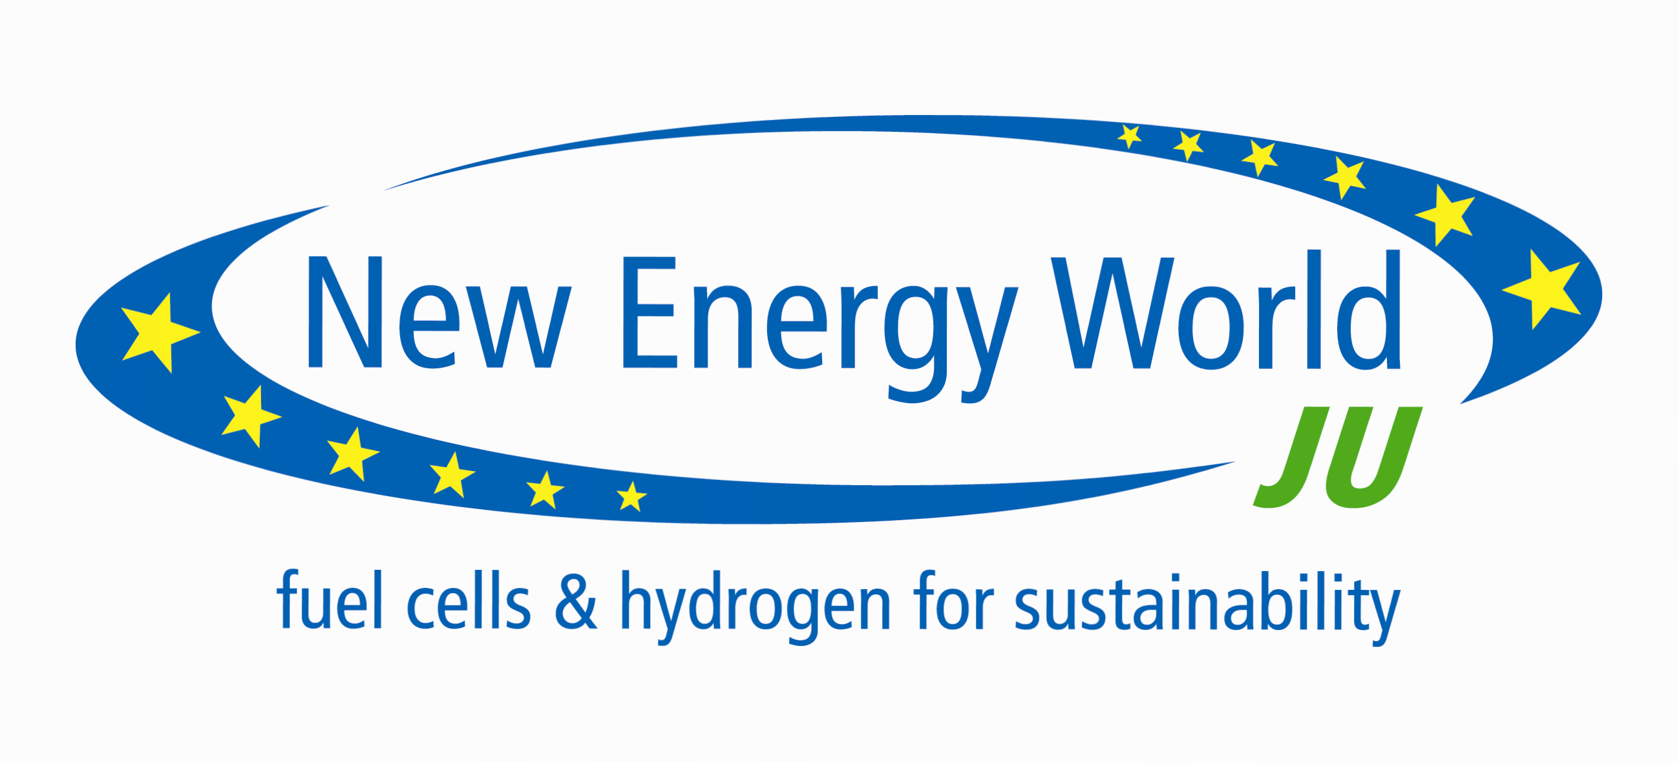

Press Release

Brussels, 3 May 2011

Fuel Cells and Hydrogen public-private partnership dedicates more than €200 million to support research and demonstration activities in these energy technologies

The Fuel Cells and Hydrogen Joint Undertaking whose total budget amounts to nearly €1bn to be invested by 2013, publishes its fourth annual call for proposals today, confirming the clear commitment to make these modular technologies deliver their environmental and economic benefits across various sectors: transport, power generation, industrial equipment and consumer devices. In the context of ambitious European objectives towards a low carbon economy, an increased energy security, reduced oil dependance and the delivery of improved power management, the contribution of these green technologies is essential to address current challenges while sustaining EU competitiveness and job creation.
Offering high efficiency, efficient use of energy, notably renewables, in addition to limited C02 emissions and noise, these energy technologies allow Europe to stay the course in the international competition from US, Japan, Korea and China. Over € 200 million's worth have been allocated for their support through research and demonstration projects with € 109 million by the European Commission matched by in-kind contributions from industrial partners.

Welcoming the launch of this fourth call, the newly elected Chairman of the Industry Grouping of the Joint Undertaking, Pierre-Etienne Franc, underlines:
"Fuel cells and hydrogen technologies are increasingly being seen as playing an important role in both a cleaner transport sector and a more efficient energy system at European level. The deployment of fuel cells and hydrogen cars is now entering a strategic phase, targeting European wide markets. Therefore appropriate funding for RTD and demonstrationprojects, as well as sufficient support for refuelling infrastructure build- up, together with favourable regulatory frameworks are a prerequisite to pave the way for market introduction and customer acceptance of these innovative technologies".

Bert De Colvenaer, Executive Director of the FCH Joint Undertaking, adds: "This is the biggest of all calls planned for the duration of the programme. We are determined, notably with shorter administrative timelines, to support the commercial deployment of fuel cells and hydrogen technologies, which now enters into a critical phase towards a wider market entry. In parallel to the call for proposals 2011 and in support of the wide deployment of the fuel cell and hydrogen technology, we are currently drafting the specifications for a series of studies on further European fuel cells and hydrogen 'Roll Out' and commercialisation plans for vehicles, stationary applications, busses and material handling vehicles. We intend to launch a public procurement for these studies later this year".
Acceleration to market entry of fuel cells and hydrogen technologies
The 36 topics of the call address key issues to foster market breakthroughs. As last year, they are divided in 5 application areas: transportation and refuelling infrastructure; hydrogen production and distribution; stationary power generation; and early markets, such as portable, micro applications or handling vehicles. The fifth application area focuses on cross-cutting issues aiming to address non-technical barriers, such as development of life cycle assessment, codes and standards, socio-economic research, public awareness, training etc...
However 70% of the funding will be dedicated to transport and refuelling infrastructure and to stationary applications. This reflects that the commercialisation of fuel cells electric vehicles is recognised as a market push for other applications, as well as the wide potential of stationary applications.
Next steps
The deadline for application is 18 August 2011. Evaluation of proposals will be carried out in September 2011 and projects selected for contract negotiations should be announced already by the end of December 2011.
Background
The Fuel Cells and Hydrogen Joint Undertaking was established on 14 October 2008 as the first illustrative example of a public-private partnership instrument under the European Strategic Energy Technology Plan (SET-Plan), technology pillar of the EU's energy and climate policy. Autonomous since 15 November 2010, the FCH JU aims to speed up the development of fuel cell and hydrogen technologies in Europe to enable their commercialisation between 2010 and 2020. Current membership includes the European Commission and 54 companies, from multinationals to SMEs represented by the Industry Grouping (NEW-IG), as well as over 55 universities and research institutes, represented by the Research Grouping (N.ERGHY) engaging more than 2000 researchers in the field of fuel cells and hydrogen.
For more information
The FCH JU will hold a Public Information Session on 12 May 2011 from 14:30 to 17:30 in Tour Madou, 1 Place Madou, Brussels, which will cover the different topics of the call, the process, the rules for submission of proposals as well as other useful information. To get more information and for registration (compulsory for security access purposes) please contact fchju@fch.europa.eu.
A brokerage event will also be co-organized by the Industry and Research Groupings of the Joint Undertaking on 19 May 2011, in Berlin. This event aims to offer to participants the opportunity to discuss concrete project ideas, find and meet with potential partners within their respective application areas, build or join a consortium, as well as enlarge their network. To get more information and register for the event, please contact the Industry grouping (secretariat@fchindustry-jti.eu) or the Research Grouping (secretariat@nerghy.eu).

Call information:

http://www.fch-ju.eu

http://cordis.europa.eu/fp7/dc/index.cfm?fuseaction=UserSite.FP7DetailsCallPage&call_id=309

Contact: Claire Castel, Communication Officer, Fuel cells and Hydrogen Joint Undertaking, Email: Claire.Castel@fch.europa.eu, Tel: +32 2 221 81 35

