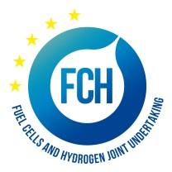
PRE-INFORMATION NOTICE
Negotiated procedure for a mobile hydrogen refueling station (HRS)
Fuel Cells and Hydrogen 2 Joint Undertaking (FCH 2 JU) is planning to award a contract for the supply of a mobile HRS

FCH 2 JU is planning to contract a supplier of a mobile hydrogen refueling station (HRS) in order to accompany and refuel fuel cell powered vehicles (cars/buses).
FCH 2 JU is planning 2 events for which the mobile HRS will be needed, one event in March 2019 in Strasbourg, France and the other in June 2019 in Bucharest, Romania. The contract might cover the supply of HRS for both events.
FCH 2 JU intends to invite potential candidates and send them the tender specifications with full details in the beginning of February 2019. If you would like to be considered for this contract, please express your interest by contacting the FCH 2 JU via info.procurement@fch.europa.eu by Monday 4 February 2019.
Please note that expressing interest to participate in the above-mentioned procedure does not give rise to any legitimate expectations to be invited.
This notice is in no way binding on FCH 2 JU. FCH 2 JU contractual obligation commences only upon signature of the contract with the successful candidate. Up to the point of signature, FCH 2 JU may either abandon the procurement or cancel the award procedure, without the candidates being entitled to claim any compensation. Candidates will be notified of the decision to abandon or to cancel the procedure if applicable.

