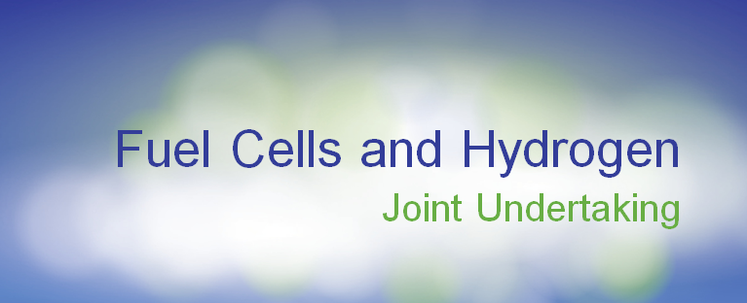

**DRAFT AGENDA**

**“Towards the deployment of Fuel Cells and Hydrogen technologies”**

**5 October 2011 - 12h30- 18h30**

**European Parliament, Brussels**

**Meeting room 6 Q 1, JAN Building**

**12.00:** Registration and access to European Parliament

|  |  |
| --- | --- |
| **12h30 - 14h30** | **Networking Lunch, Ground floor “Couloir Cheval”** |

**15.00 - 15.15:** Welcome to FCH JU thematic session, Ms Maria da Graça **Carvalho** MEP

**15.15 - 15.30:** Introducing Fuel cells and Hydrogen Joint Undertaking, Mr Bert **De Colvenaer**, FCH JU Executive Director

**15.30 - 16.30:** Highlight on supported projects

* FITUP: Mrs Ilaria **Rosso**, Electro Power System
* CHIC: Mrs Monika **Kenzler**, Daimler
* HYLIFT- Demo: Mr Jacob **Krogsgaard**, H2 Logic

|  |  |
| --- | --- |
| **16h30 - 16h45** | **Coffee break** |

**16.45 - 17.45:** Towards the deployment of FCH technologies

*Introductory remarks: moderator Mr Bert De Colvenaer, FCH JU Executive Director*

* Mr Rudolf **Strohmeier**, Deputy-Director General, Scientific advances, DG RTD, European Commission
* Mr Henri **Winand**, CEO of Intelligent Energy and Treasurer of the FCH JU New IG
* Mr Bernard **Frois**, Chair of the FCH JU States Representatives Group
* Mr Paul **Lucchese**, Chair of the FCH JU Research Grouping
* Prof. Jose C. **Fernandes Pereira**, IST, Mechanical Engineering Department-LASEF
* Mr Jo **Leinen**, MEP, Chair of ENVI Committee
* Mrs Anni **Podimata**, MEP, Vice-Chair of ITRE Committee
* Mr Reinhard **Bütikofer**, MEP, Member of ITRE Committee (tbc)
* Mr Vittorio **Prodi**, MEP, Member of ENVI Committee
* Mr Mathieu **Grosch**, MEP, Member of the TRAN Committee (tbc)

**17.45 - 18.25:** Q&A session

**18.25 - 18.30:** Wrap up/conclusions: Ms Maria da Graça **Carvalho**, MEP

|  |  |
| --- | --- |
| **18h30** | **Cocktail, Ground floor “Couloir Cheval”** |

