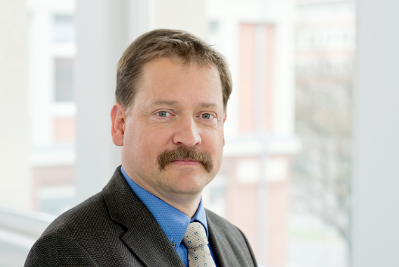

MAIR Georg Wilfried
BAM Bundesanstalt für Materialforschung und -prüfung
Berlin (Germany)
Head of Section “Focus Area Energy – Gases” in
Department 3 “Containment Systems for Dangerous Goods”
e-mail: georg.mair@BAM.de

Curriculum

Dr.-Ing. Georg W. Mair has focused his research studies on safety of gas storage and relevant probabilistic risk assessments in the last twenty-five years. Since 1996 he has been working for BAM Bundesanstalt für Materialforschung und -prüfung (Federal Institute for Materials Research and Testing). There, he is responsible for the section that executes the duties, for which BAM is competent authority for international gas transport. Since 1997 he has been an advisor of the Federal Ministry for Transport and a permanent member of the German delegation at United Nations for the transport of dangerous goods. In 2004 he became a member of the national advisory council on gas-powered vehicles for the ministry of transport. He is engaged in the GTR discussions on hydrogen vehicles since 2005. This also implements participation in relevant standardisation of CEN and ISO.
As a member of the executive committee of the integrated project StorHy (2003 – 2008; 6th frame work program of the EU) he has been involved in HySafe and the organisation of the international conferences of Hydrogen safety (ICHS). Due to his responsibility for the StorHy-subproject “Safety Assessment and Requirements” (SAR) he developed an approach for evaluation and reduction of unnecessary safety margins. Thus, he started to work on a new concept for the approval of composite gas cylinders for onboard storage (probabilistic approach) and retesting of cylinders for the transport of dangerous goods (destructive testing parallel to operation). In the meantime, he has been involved in some EU-projects as e.g. INGAS, HyComp, HyCube, FiBreMoD,TAHYA and several national projects.
He is the author of two books and has published more than 100 papers in the fields of testing, approval requirements and risk assessment of composite pressure vessels with special focus on the storage of hydrogen as an energy carrier.

