Joint Technology Initiatives: Innovation in action
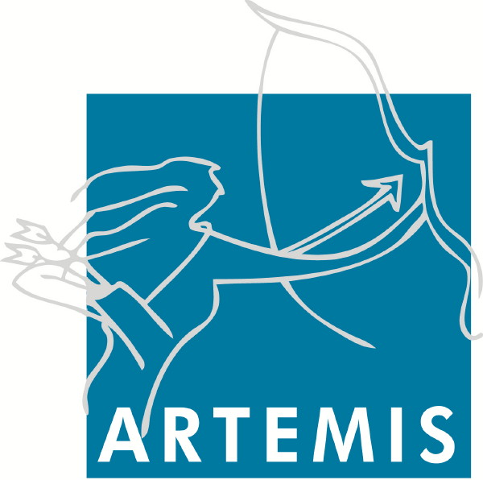
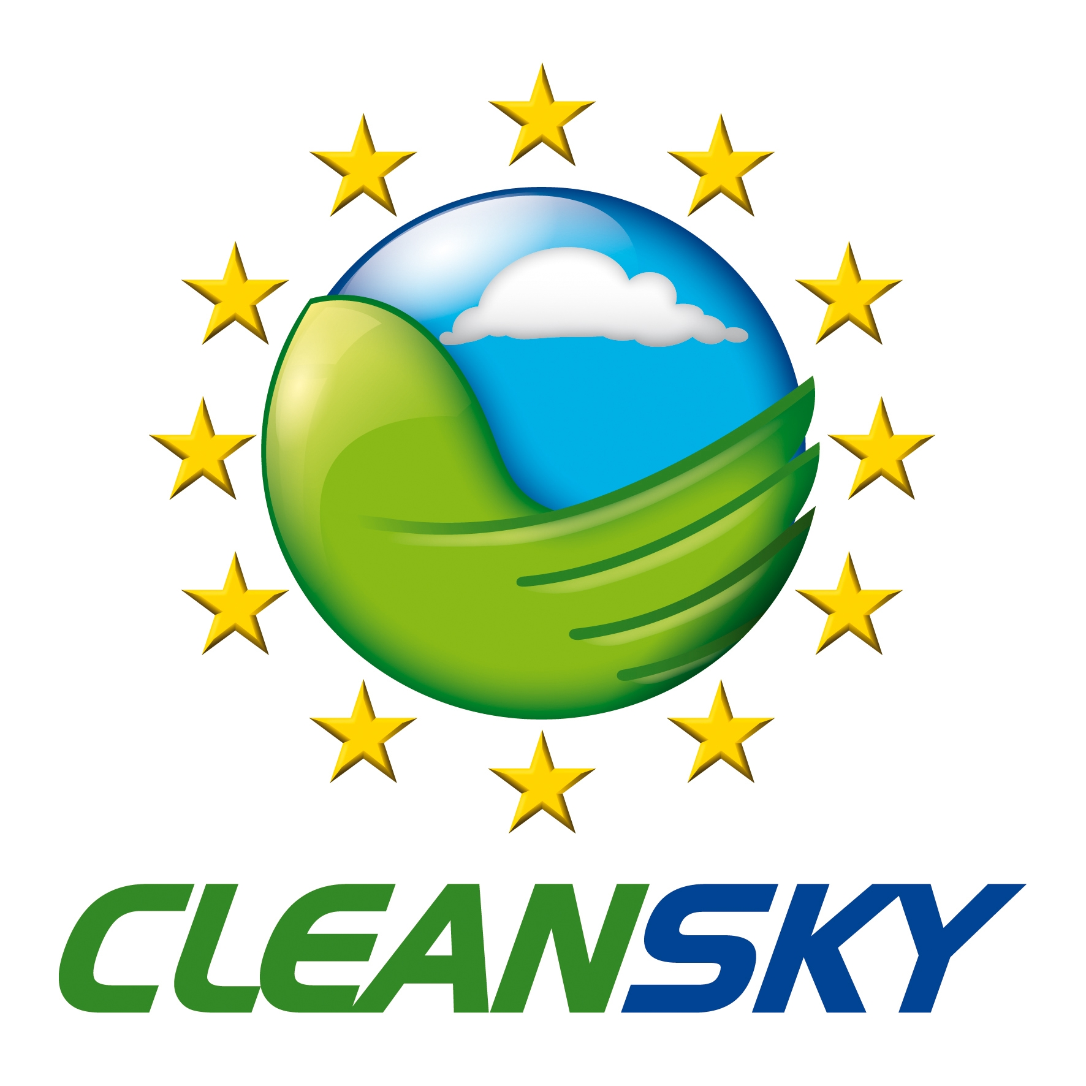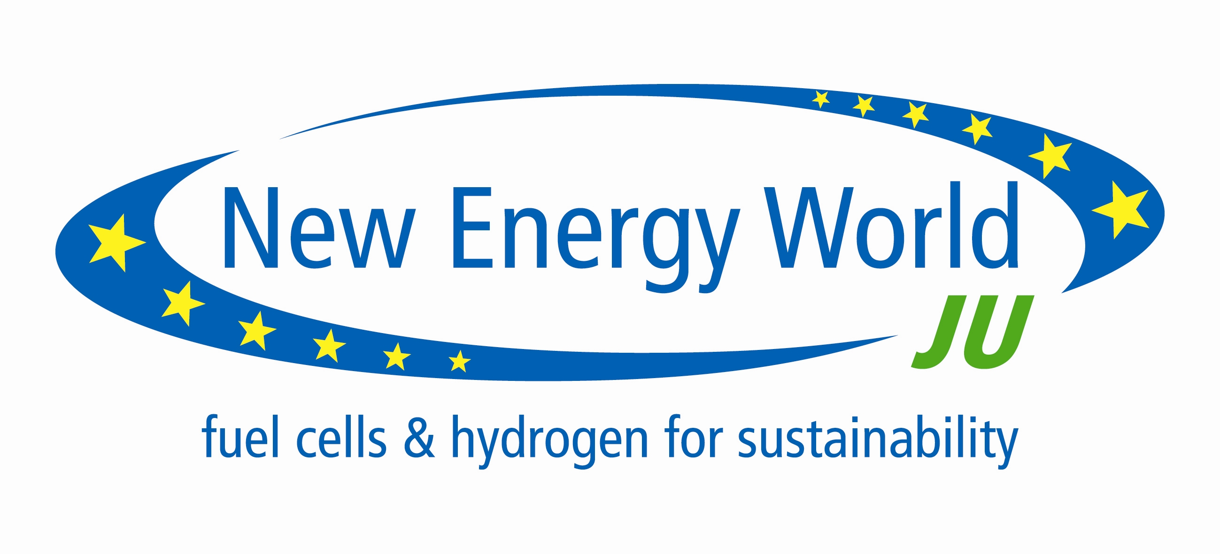

Joint exhibition
European Parliament
Ground floor “Couloir cheval”
3/6 October 2011

Monday 3 October
Early Morning | Setting
12.30 | Stands have to be in place

Tuesday 4 October
9.30- 12.30 | Thematic session ARTEMIS
15.00 – 18.00 | Thematic session ENIAC
18.45 | Opening (Joint presentation ARTEMIS, ENIAC, FCH, CLEAN SKY and IMI) + Key note speech of Ms Maria da Graça CARVALHO, MEP
19.00 | Cocktail - ASP Ground floor, couloir Cheval

Wednesday 5 October
9.30- 12.30 | Thematic session CLEAN SKY
15.00 – 18.00 | Thematic session FCH (room 6Q 1, Jan Building)
18.45 | Key note speech of Ms Maria da Graça CARVALHO  and Mr Lambert van NISTELROOIJ, MEPs
19.00 | Cocktail –ASP Ground floor, couloir Cheval

Thursday 6 October
9.30- 12.30 | Thematic session IMI
15.00 – 17.00 | Closing session (ARTEMIS, ENIAC, FCH, CLEAN SKY and IMI) in the presence of press- ground floor – couloir Cheval

