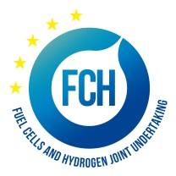

PRE-INFORMATION NOTICE
Negotiated procedure for a study on supply chain for Hydrogen and Fuel Cells Technologies

Fuel Cells and Hydrogen 2 Joint Undertaking (FCH 2 JU) is planning to award a contract for carrying out a study on supply chain for Hydrogen and Fuel Cells Technologies.

FCH 2 JU is planning to contract a service provider able to carry out a study on the supply chain for Hydrogen and Fuel Cells Technologies. The objective is the analysis and mapping of the European FCH supply chain for transport and energy sectors, structured per key close-to-market applications. The study to be proposed in this tender will be concentrated on the actual status of the European FCH supply chain, benchmarking it worldwide and, based on its outcomes, will likely be followed by a more in-depth study.
FCH 2 JU intends to invite potential candidates and send them the tender specifications with full details by the end of September. If you would like to be considered for this contract, please express your interest by contacting the FCH 2 JU via info.procurement@fch.europa.eu by Wednesday 21 September 2016.
Please note that expressing interest to participate in the above-mentioned procedure does not give rise to any legitimate expectations to be invited.
This notice is in no way binding on FCH 2 JU. FCH 2 JU contractual obligation commences only upon signature of the contract with the successful candidate. Up to the point of signature, FCH 2 JU may either abandon the procurement or cancel the award procedure, without the candidates being entitled to claim any compensation. Candidates will be notified.

