Dipl.-Ing. (TU) Wolfram SCHWAB
Member of the FCH 2 JU Governing Board

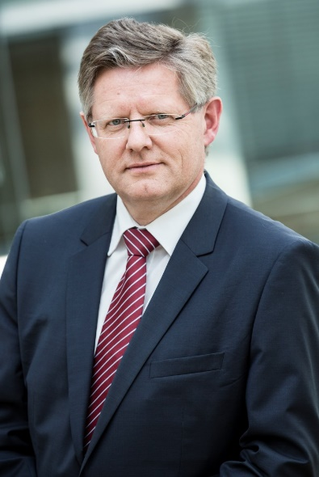

Vice President R&D and Innovation at Alstom Transport
Member of the FCH 2 JU Governing Board

Dipl.-Ing. (TU) Wolfram Schwab studied Mechanical Engineering and Railway Engineering at the University of Hannover, Germany and has over 34 years’ experience in the Rail Industry. Additionally he is certified as welding engineer at SLV Berlin in 1988. Wolfram is a leading expert on Hydrogen Fuel Cell technology as it pertains to rail vehicles.
fch
Since 2018 he is Vice President of R&D and Innovation at Alstom Transport (R&D and Innovation for Rolling Stock, Systems, Infrastructure, Service and Digital Mobility).

