

TRUST
(Technology Reporting Using Structured Templates)

User Manual
Version 1.00

Table of contents
TRUST 3
How do I create a project? 3
How do I update a project? 5
How do I create a new template? 6
How do I update a template? 8
How do I create a reference period? 9
I am a data provider. How do I view the list of Research Object Forms? 11
I am a data provider. How do I view or update a Research Object Form? 12
I am a project manager. How do I view the list of research object forms? 14
I am a project manager. How do I view or update a research object form? 16
How do I view the actions that have been performed on a research object form? 18
How do I change my profile information? 21

TRUST
The aim of this document is to provide users of TRUST application with the skills required to navigate and operate through the various screens of TRUST application.

How do I create a project?
- Login from https://trust.fch.europa.eu/ui/ as a administrator
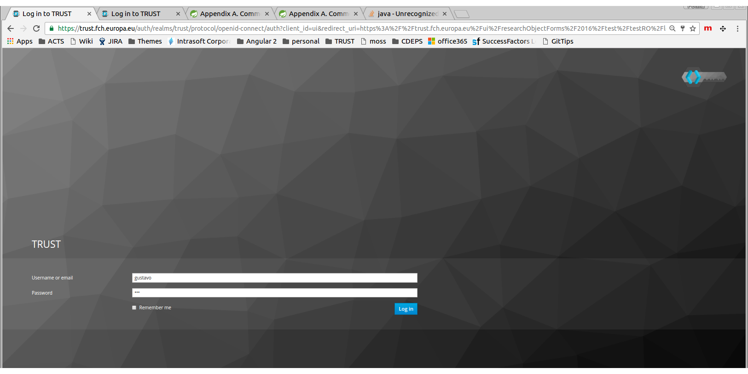
- Click on the option “Create Project” from the menu.
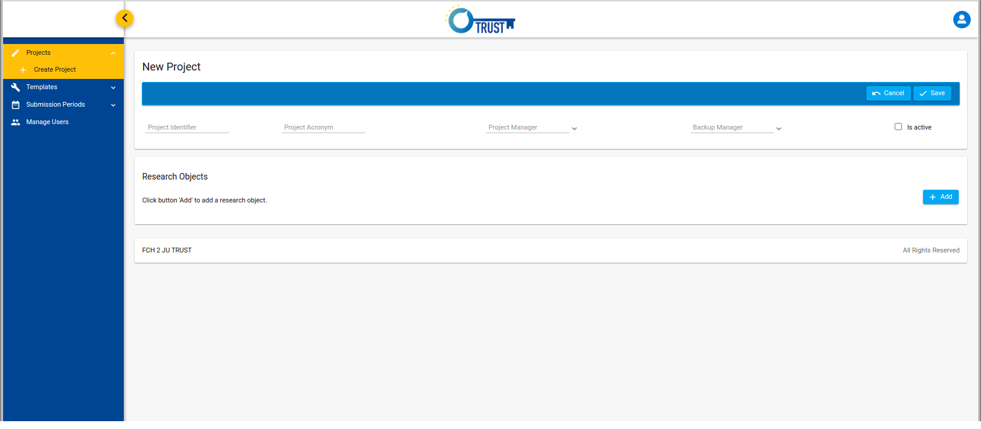

- A screen will appear in which you are prompted to provide the following fields

- Project Identifier: The id of the project (no special characters or spaces are allowed in this field)
- Project Acronym: The name of the project as it will appear in the forms.
- Project Manager: The project manager.
- Backup Manager: The backup manager of the project
- Is active: A flag that indicates if the project is active or not. If the project is inactive no research object forms are registered for this project.

- Click on “Add” button in order to create a new research object for the new project.

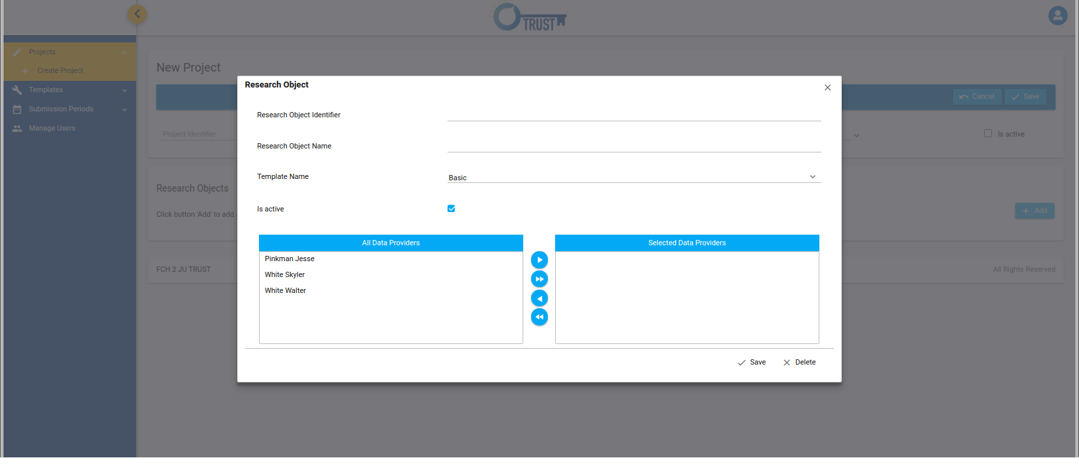

- A pop-up window will appear in which you can provide the details of the research object.
- Research Object Identifier: The id of the research object (no special characters or spaces are allowed in this field).
- Research Object Name: The name of the research object as it will appear in the forms,
- Template Name: the name of the template that the research object will use.
- Is active: a flag that indicates if the research object is active or not.
- Data Providers: The list of data providers that are assigned to the research object.

- Click on “Save” button of the pop-up window in order to save the research object in the project.
- Click on the “Save” button of the “New Project” screen in order to save the project in the database.

- If there are validation errors a red panel will appear that will display them. Correct the errors and press again the “Save” button.

- If the action is executed successfully a green panel will appear with an informative message.

How do I update a project?
- Login from https://trust.fch.europa.eu/ui/ as an administrator.

- Click on the option “Projects” from the left menu.
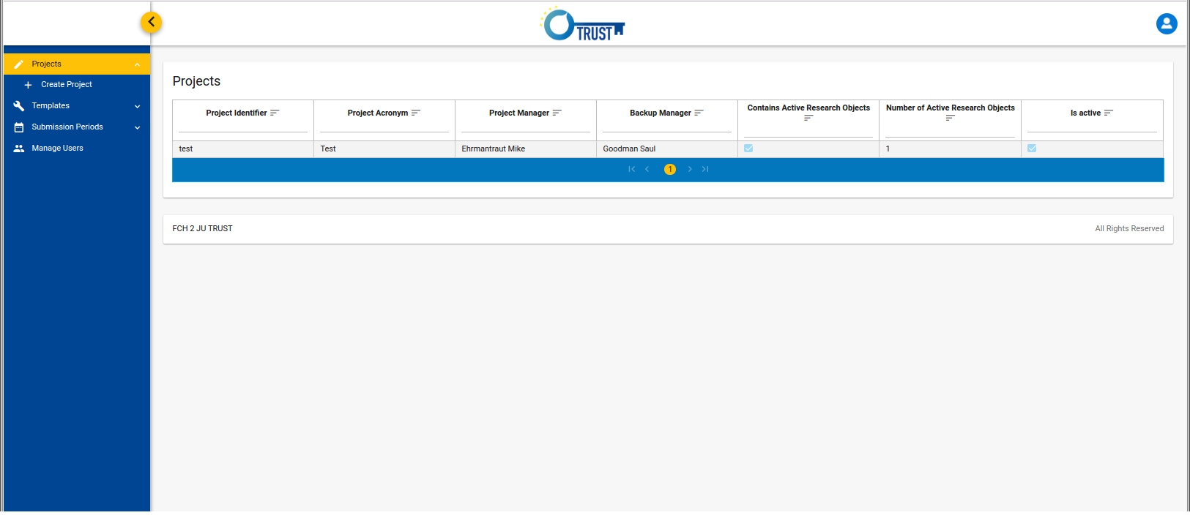
- A screen will appear with a list of all registered projects. You can sort the list by clicking the icon next to the column headers. You can also filter the results of the list by typing a text below the column header.
- Click on a table row in order to select the project that you want to update.
- A screen will appear with all the details of the selected project.
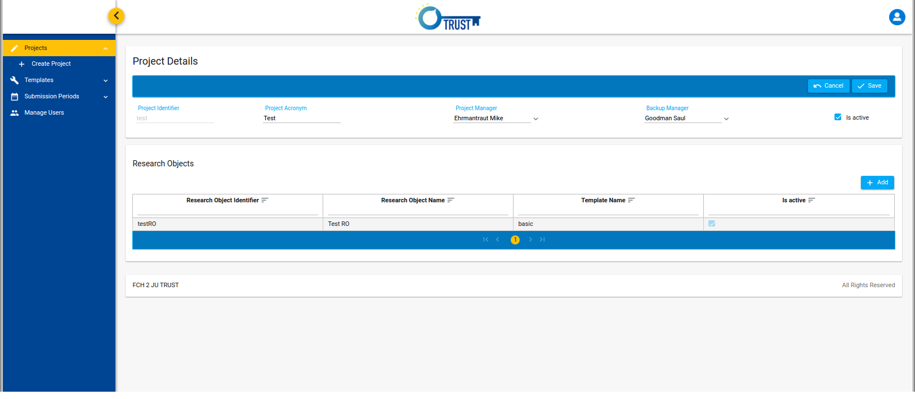
- Edit the project and click the button “Save” in order to save the changes in the database.
- If the execution of the action is successful a notification message will appear in a green panel.
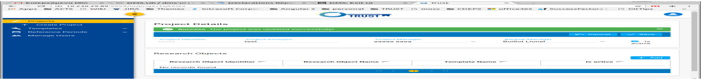

How do I create a new template?
- Login from https://trust.fch.europa.eu/ui/ as an administrator.

- Click on the option “Templates” -> “Create Template” from the left menu.

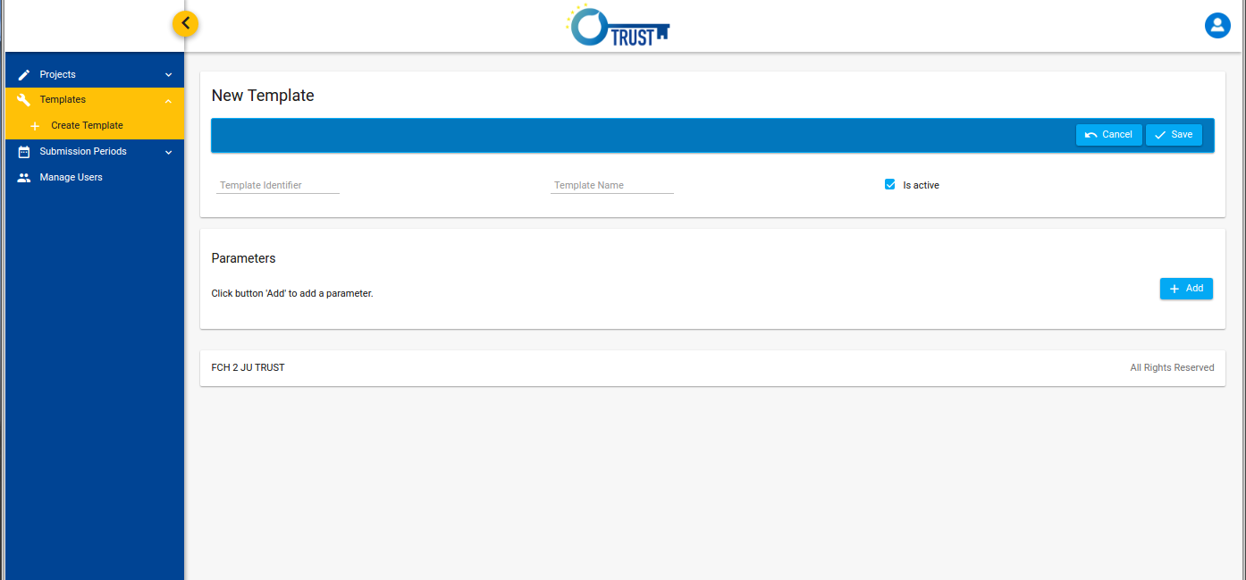
- The screen “New Template” will appear in which you are prompted to provide the details of the new template.
- Template Identifier: the id of the new template. It is unique and cannot contain spaces and special characters.
- Template Name: the name of the template as it will appear in the forms.
- Is active: flag that indicates whether the template is active or not.

- Click on the “Add” button in order to add parameters to the new template.

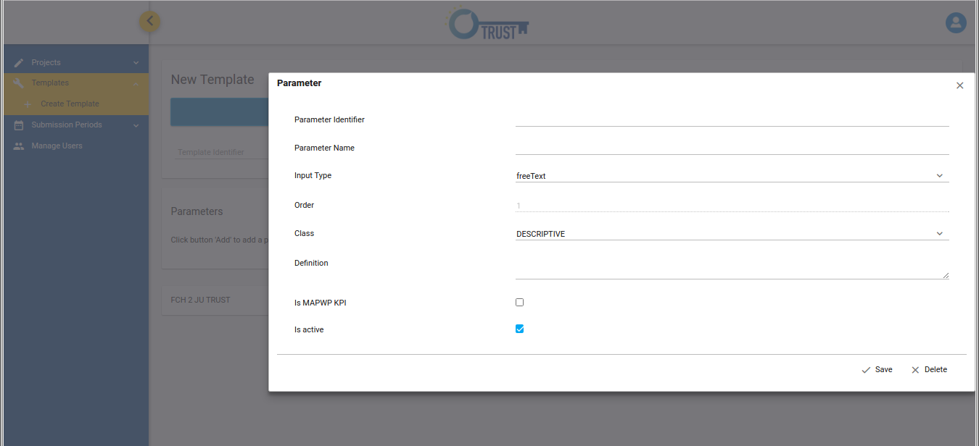
- A pop-up window will appear in which you provide the parameter details.
- Click on the “Save” button of the pop-up in order to save the new parameter in the template.

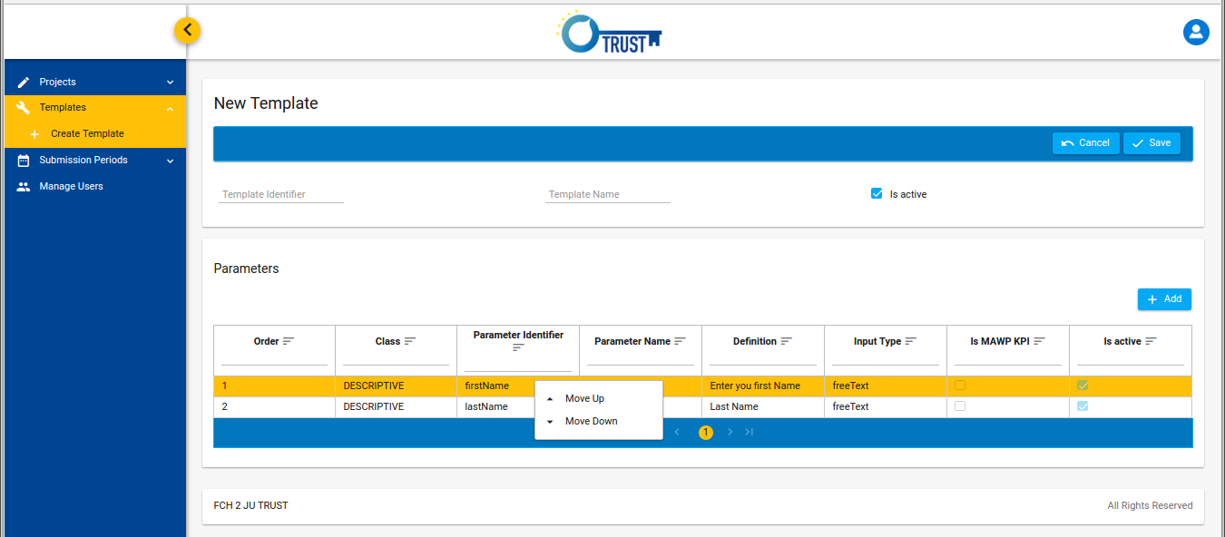
- A table with all the parameters will appear. If you want to edit the details of a parameter click on the corresponding table row. If you want to change the order of the parameter right click on a row and choose either “Move up” or ”Move down”.
- Click on the “Save” button of the “New Template” screen in order to save the template in the database.
- If the execution of the action is successful a notification message will appear in a green panel. Otherwise you will be prompted to correct the validation errors.

How do I update a template?

- Login from https://trust.fch.europa.eu/ui/ as an administrator.

- Click on the option “Templates” from the left menu.
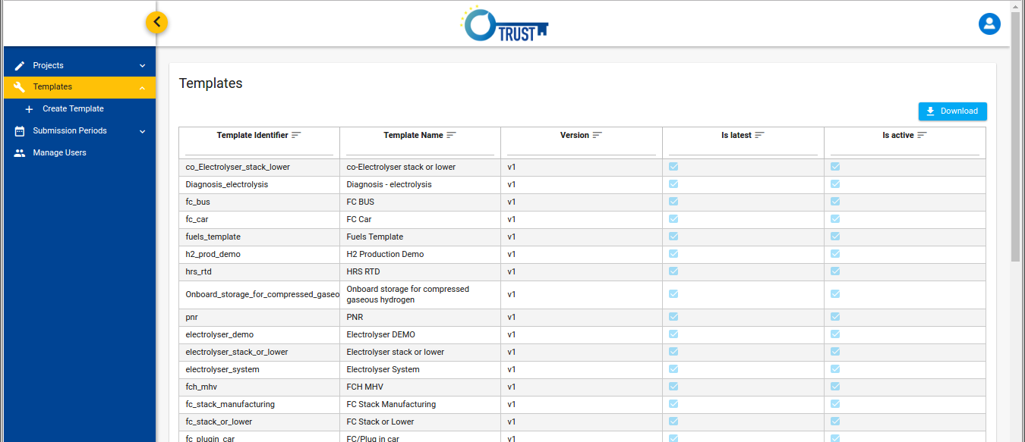
- A table with all the registered templates is appeared. You can sort the list by clicking the icon next to the column headers. You can also filter the results of the list by typing a text below the column header (or “true/false” for boolean columns).
- Select the template that you want to edit by clicking on the corresponding row in the list of Templates. A screen with the Template Details will appear. Note that only the latest version of a template can be updated.
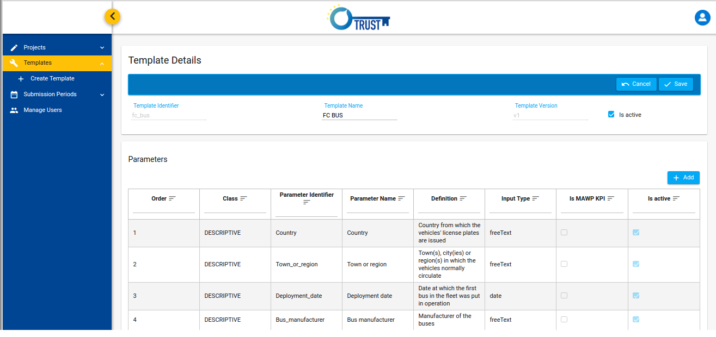

- Edit the content of the template and click the “Save” button in order to save the changes in the database. A new version of the template will be created.

How do I create a reference period?

- Login from https://trust.fch.europa.eu/ui/ as an administrator.

- Select the option “Reference Periods” from the left menu.
- A list with all the registered reference periods is displayed.
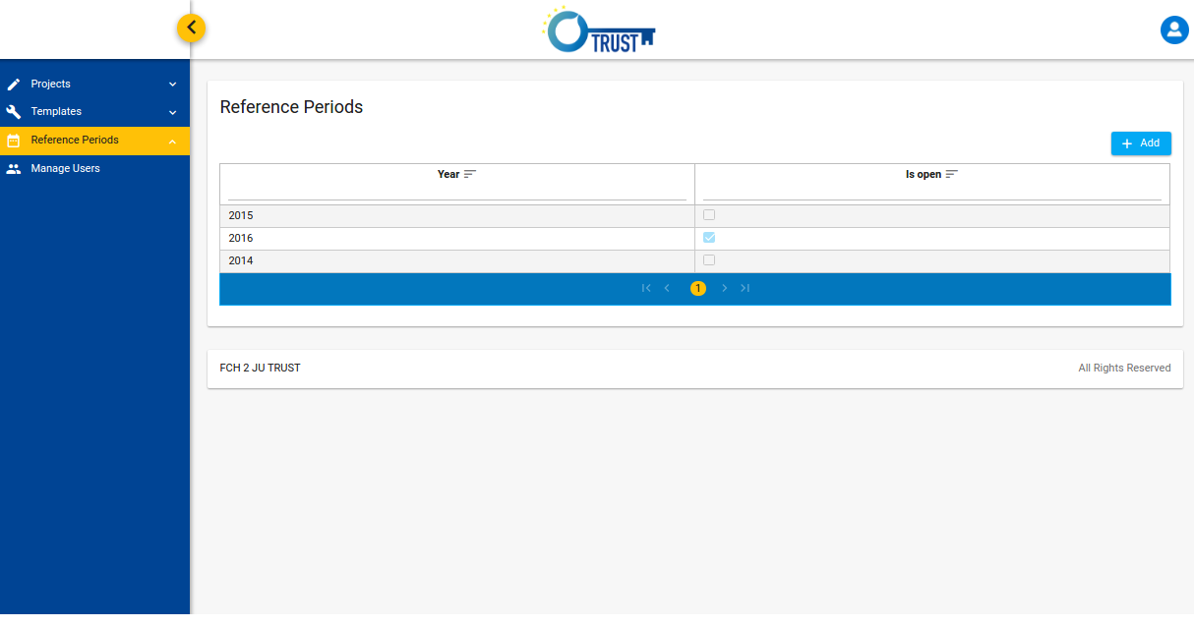
- Click the button “Add” in order to create a new reference period. A pop-up window is displayed in which you have to enter the year and indicate whether the new period will be an open one or not. Note that only one reference period can be open.
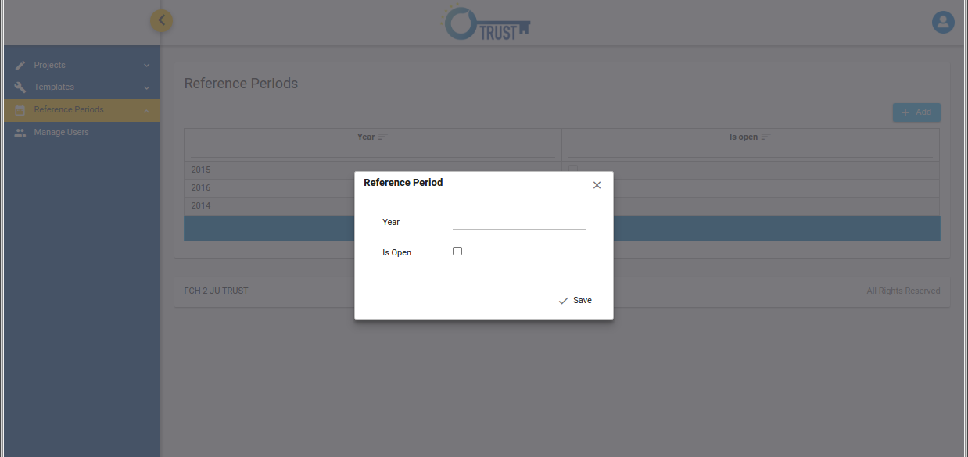
- Click the “Save” button of the pop-up in order to save the new period in the database.
- If you want to change the status of a reference period, that is to declare it as an open one or not, click on a row in the reference periods table and change the value of the “Is open“ checkbox.

I am a data provider. How do I view the list of Research Object Forms?
- Login from https://trust.fch.europa.eu/ui/ as a data provider.

- A screen with the Research Object Forms is displayed for the open reference period.
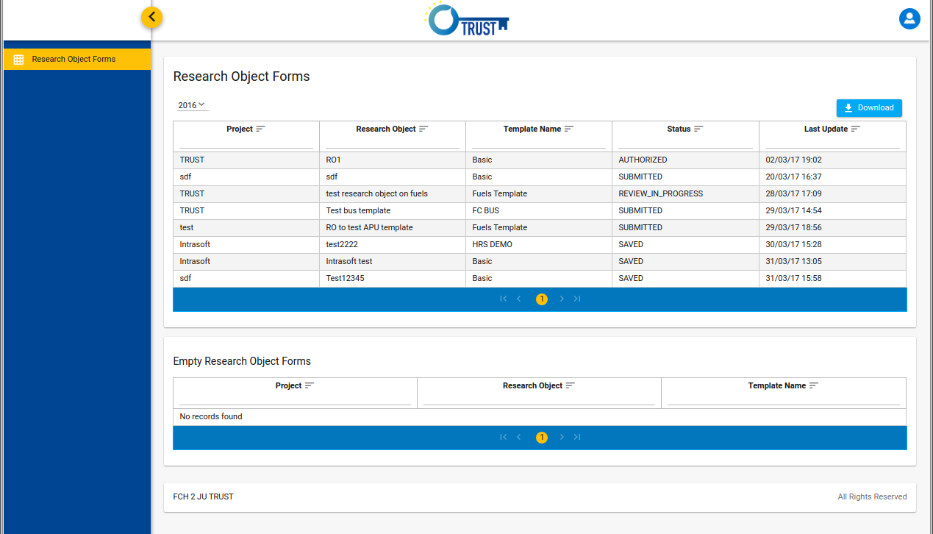
- In the screen two tables are presented. The first table includes the forms that have already been saved, whereas the second one contains the empty forms, those that have never been saved. You can sort each table by clicking the icon next to the column headers. You can also filter the results of a list by typing a text below the column headers.
- Click the “Download” button in order to export the Research Object Forms in an excel file.
- Select a different reference period from the drop down list, 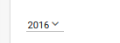 in order to see the forms that have been registered for this year.

I am a data provider. How do I view or update a Research Object Form?
- Login from https://trust.fch.europa.eu/ui/ as a data provider.

- A screen with the Research Object Forms assigned to you is displayed for the open reference period. You can sort the lists by clicking the icon next to the column headers. You can also filter the results of the lists by typing a text below the column headers.
- Select the form that you want to update by clicking on the corresponding row.
- A screen with the content of the selected form is displayed.
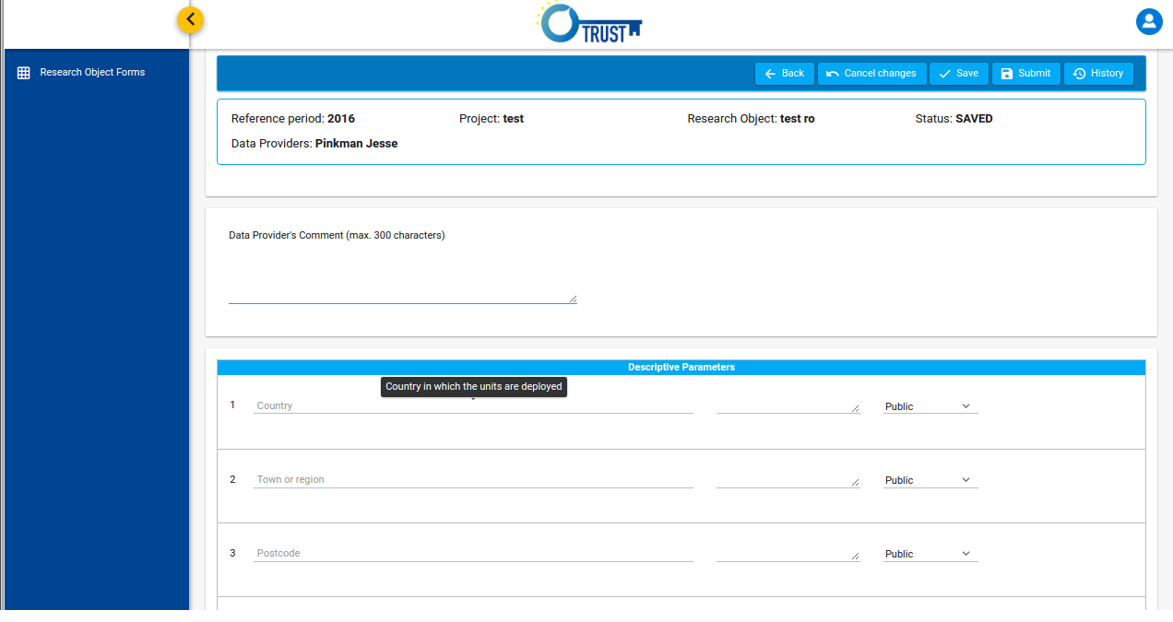
- Move the mouse over the label of a field in order to see its definition.
- Change the fields of the form that are editable and click on button “Save” in order to save the changes in the database or the button “Submit” in order to submit the form. After the successful submission of the form you won’t be allowed to change the form.
- In case there are validation errors a red panel will appear that will list all of them. Correct the errors and execute the action again. If the execution of the action is successful a notification message will appear in the screen.
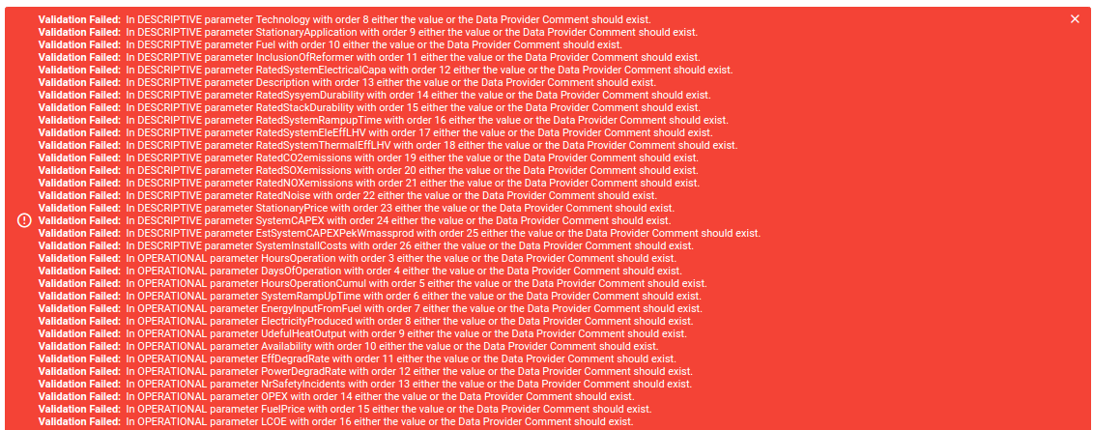

- Click the button “Back” in order to return to the previous screen with all the research object forms assigned to you for the open reference period.
- If you try to leave the form’s page a confirmation window will appear which warns you that unsaved changes may exist. Click on button “Yes” in order to leave the form’s page or “No” in order to remain to it.
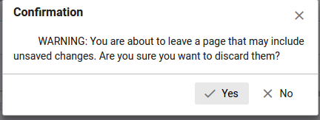

I am a project manager. How do I view the list of research object forms?
- Login from https://trust.fch.europa.eu/ui/ as a project manager.

- A screen with the Research Object Forms is displayed for the open reference period. That list includes the forms that belong to projects in which you are a project manager. You can sort the list by clicking the icon next to the column headers. You can also filter the results of the list by typing a text below the column headers.
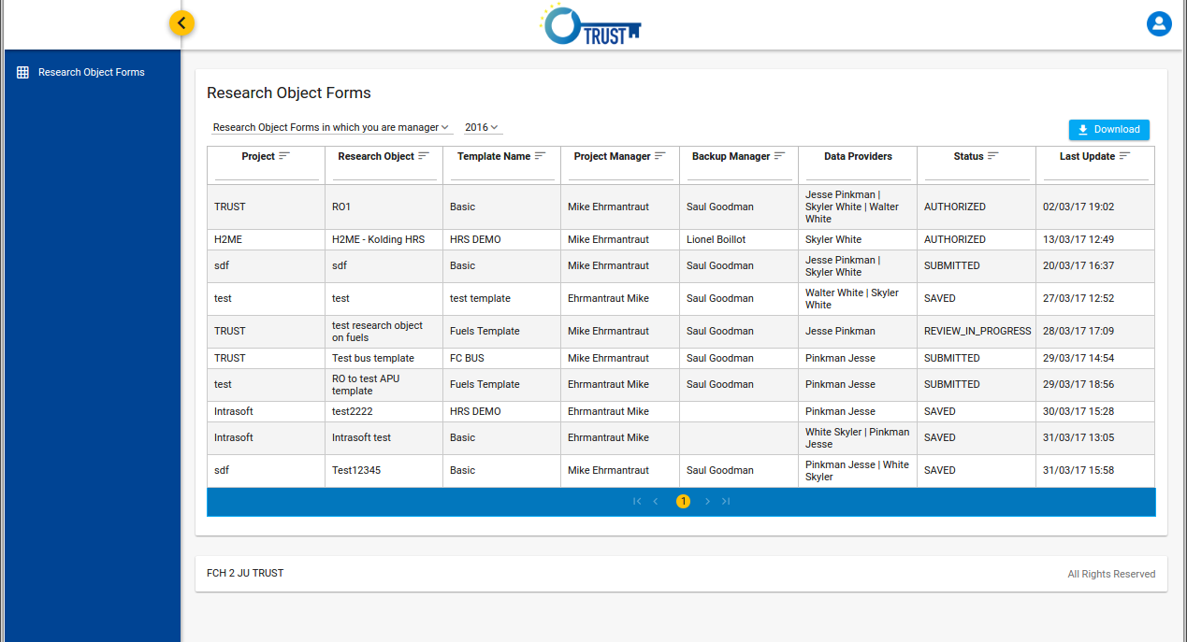
- Click the “Download” button in order to export the research object forms in an excel file.
- Select a different reference period from the drop down list, in order to see the forms that have been registered for this year.
- Change the selected option of the drop down list in order to view the forms in which you are a backup manager or all the research object forms.
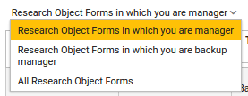

I am a project manager. How do I view or update a research object form?
- Login from https://trust.fch.europa.eu/ui/ as a project manager.

- A screen with the Research Object Forms is displayed for the open reference period. That list includes the forms that belong to projects in which you are a project manager. You can sort the list by clicking the icon next to the column headers. You can also filter the results of the list by typing a text below the column headers.
- Select the form that you want to update by clicking on the corresponding table row.
- A screen with the content of the selected form is displayed.
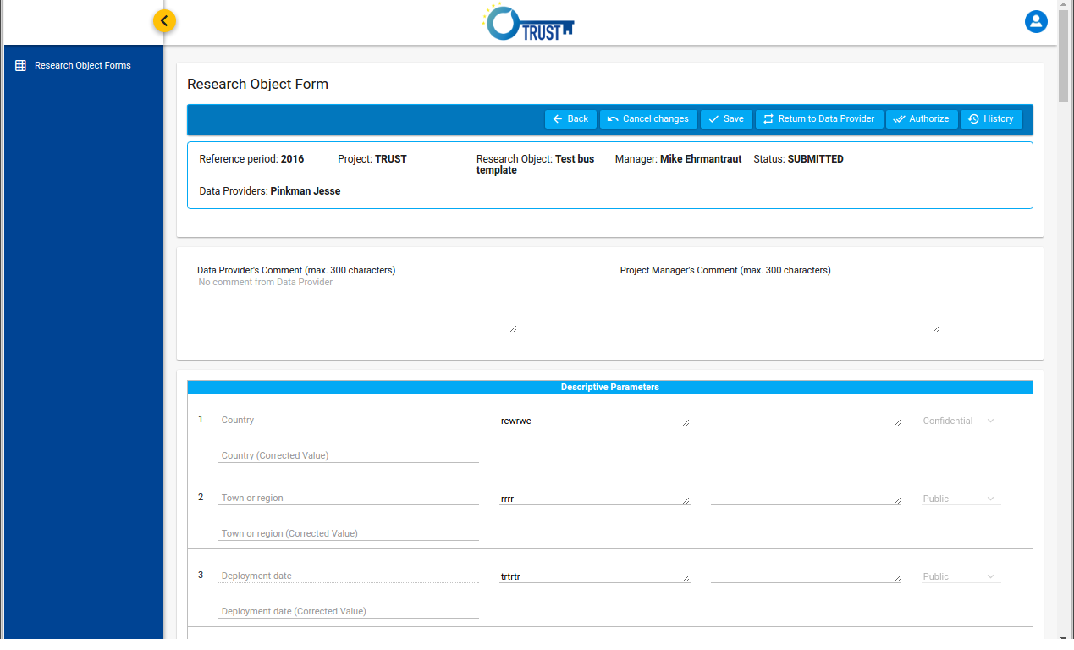
- Change the fields of the form that are editable and choose one of the available buttons.
- Click the button “Save” in order to save your changes in the database.
- Click the button “Authorize” in order to change the status of the form to AUTHORIZED. After the successful execution of this action you will no longer be able to edit the form.
- Click the button “Return to Data Provider” in order to change the status of the form to SAVED. A pop-up will appear in which you are prompted to choose the reason and provide justification for your selection. Click the “OK” button in order to register your decision to return the form to the data provider.
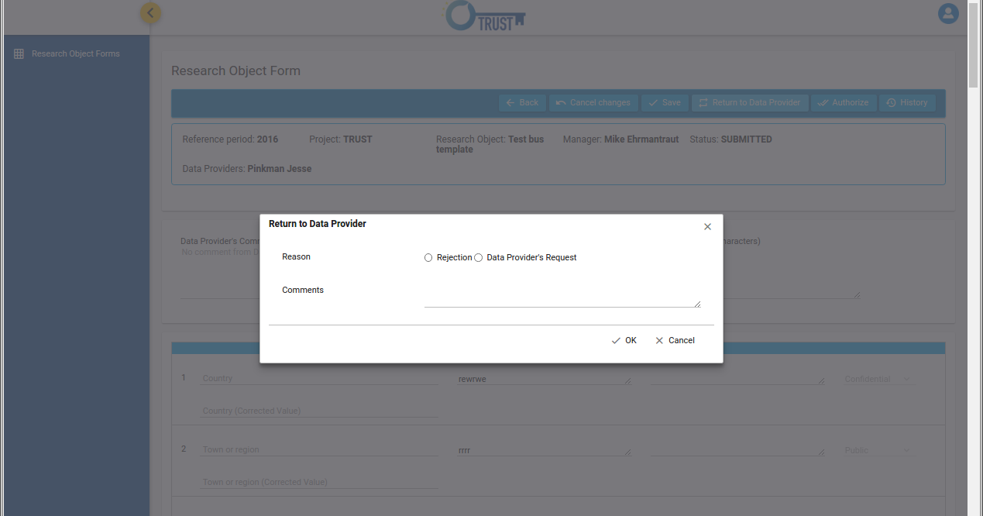

- Click the “Back” button in order to return to the screen with the list of research objects forms.
- If you try to leave the form’s page a confirmation window will appear which warns you that unsaved changes may exist. Click on button “Yes” in order to leave the form’s page or “No” in order to remain to it.

How do I view the actions that have been performed on a research object form?
- Login from https://trust.fch.europa.eu/ui/ as a project manager or a data provider.
- A screen appears with the list of the research object forms related to you for the open reference period.
- Select the form your are interested in, by clicking on the corresponding row of the table.
- A screen with the content of the selected form is displayed.
- Click on the “History” button on the top-right corner of the form.
- A screen with all the actions related to the selected form is displayed. The table with the history data includes the following information:
- User: the name of the user that performed the action
- Action: the action that executed
- Timestamp: the date and time the action was executed
- Status: the status of the form after the execution of the action
- Comments: the comments that the user has provided during the action execution
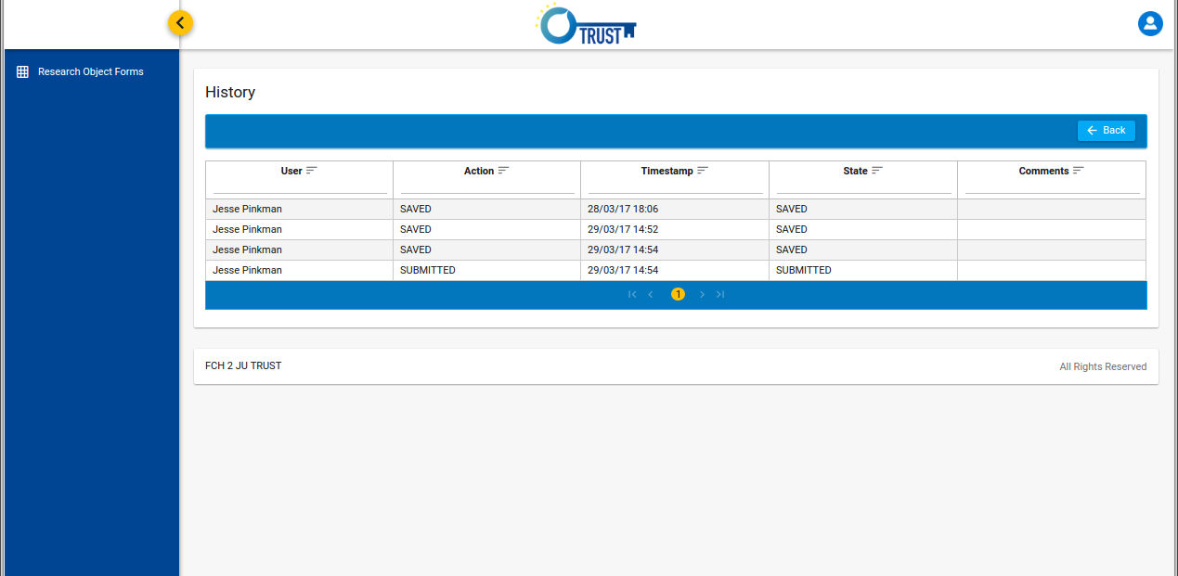
- Click on the “Back” button in order to return to the selected research object form.

How do I change my profile information?

- Login from https://trust.fch.europa.eu/ui/ as a project manager, data provider or administrator..
- Click on the top-right button of the screen and select the option “Profile”.profile

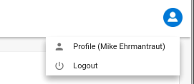
- A screen appears with your profile information.
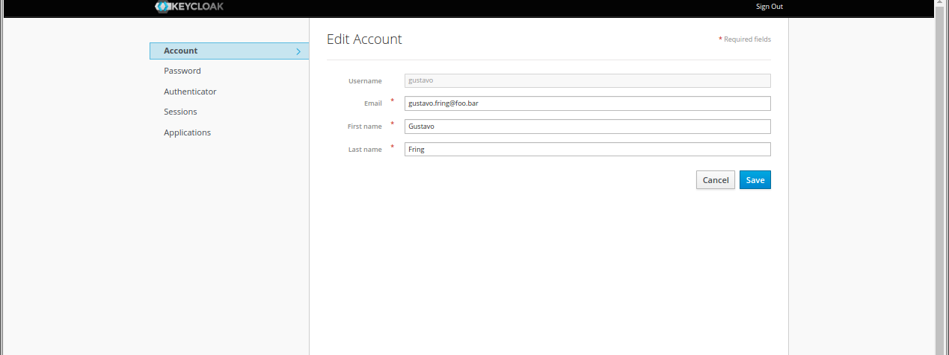
- Change the values of the editable fields and click the “Save” button to register the changes in the database.
- Select the option “Password” on the left menu in order to update your password. A screen appears in which you are prompted to provide your current password and the new one.
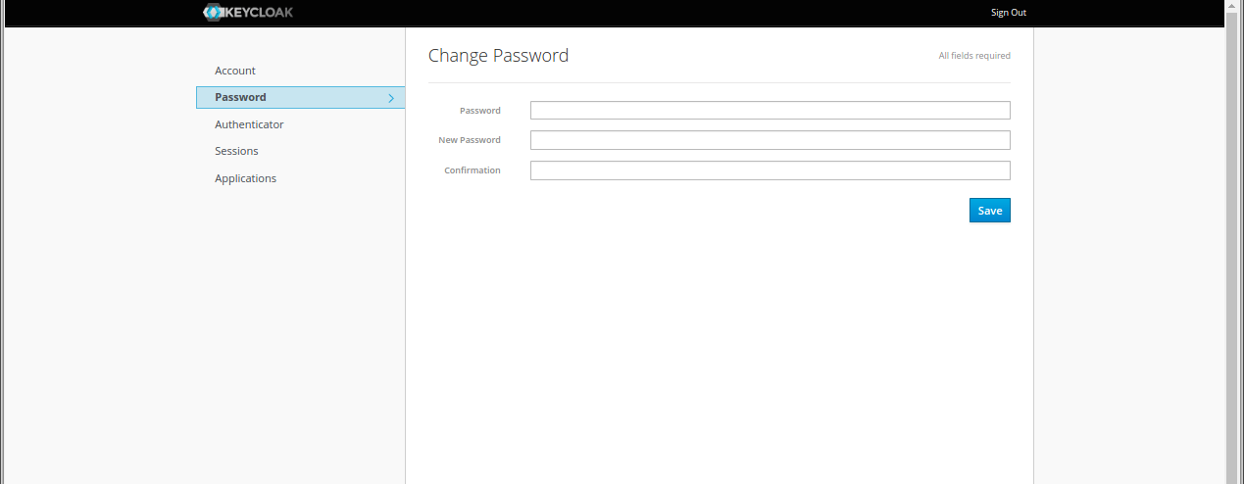
- Provide the requested data and click the “Save” button in order to save your new password in the database.

