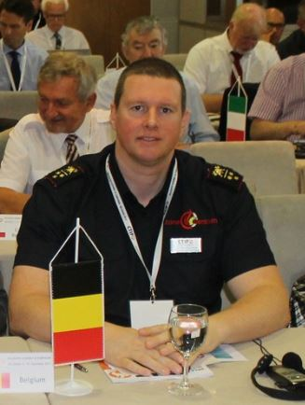

Maj. Tom Van Esbroeck
Chairman Commission for Extrication & New Technology
Chairman National Committee CTIF Belgium
Roggestraat 70 | BE-9000 Gent | Gsm +32476 94 27 21 | Tel. +32 9 268 88 99 | Fax +32 9 268 88 43
tom.vanesbroeck@brandweerzonecentrum.be

INTERNATIONAL ASSOCIATION OF FIRE & RESCUE SERVICES
Trzaska 221
1000 Ljubljana Slovenia
Phone: +386 124 197 54
contact@ctif.org – www.ctif.org

Curriculum

Tom Van Esbroeck, born in Sint-Niklaas, Belgium in 1975, began his career in 1996 as a firefighter. Over the last 19 years he has held almost every possible position in 3 different departments, starting from firefighter to deputy chief. He is an expert in different operational areas & specialities: rescue diver, hazmat officer, officer maritime incident response group and animal rescue specialist! He cooperated in different international projects.

Tom currently holds the positions of Major – Staff Officer – and Director of Education, Training and Exercise at the Professional Fire and Rescue Service of Ghent and also the position of Fire Station Manager at the Voluntary Fire and Rescue Service of Ninove.

Tom serves as an expert to the Belgian government and to the Flemish firefighting Federation. In 2013 he took up the position of chairperson of the CTIF Extrication and New Technology Commission.
The main objective of the new commission is to promote the development of best practices and standard operation procedures. The commission intends to share experiences at an international level in order to help protect our citizens and first responders.

